

Alumni Interactive System Requirements Specification

Version 2.0

May 13, 2019

Table of Contents

1. EXECUTIVE SUMMARY 3

1.1 PROJECT OVERVIEW 3

1.2 PURPOSE AND SCOPE OF THIS SPECIFICATION 4

2. PRODUCT/SERVICE DESCRIPTION 4

2.1 PRODUCT CONTEXT 4
2.2 USER CHARACTERISTICS 4

2.3 ASSUMPTIONS 6

2.4 CONSTRAINTS 6

2.5 DEPENDENCIES 6

3. REQUIREMENTS 7

3.1 FUNCTIONAL REQUIREMENTS 7

3.2 NON-FUNCTIONAL REQUIREMENTS 13
3.2.1 Product Requirements 13

3.2.1.1 User Interface Requirements 13

3.2.1.2 Usability 14

3.2.1.3 Efficiency 15
3.2.1.3.1 Performance Requirements 15

3.2.1.3.2 Space Requirements 15

3.2.1.4 Dependability 16

3.2.2 Organizational Requirements 17
3.2.2.1 Environmental Requirements 17

3.2.2.2 Operational Requirements 17

3.2.2.3 Development Requirements 18
3.2.3 External Requirements 19

3.2.3.1 Regulatory Requirements 19

3.2.3.2 Ethical Requirements 19

3.2.3.3 Legislative Requirements 19
3.2.3.3.1 Accounting Requirements 19

3.2.3.3.2 Security Requirements 19

3.3 DOMAIN REQUIREMENTS 20
4. SOFTWARE DESIGN 7
4.1 USER SCENARIOS 7
4.2 USE CASES 7
4.3 USE CASES EXTENDED 7
4.4 DATA FLOW DIAGRAMS 7
4.4 STATE DIAGRAMS 7
4.5 COLLABORATION DIAGRAMS 7
4.6 SEQUENCE DIAGRAMS 7
4.7 CLASS DIAGRAM 7
4.8 ER DIAGRAM 7
4.9 7
4.10 OBJECT DIAGRAM 7
4.11 COMPONENT DIAGRAM 7
4.12 DEPLOYMENT DIAGRAM 7

- Executive Summary

1.1 Project Overview

It seems like once you finish university, there is nothing to connect you with it anymore. However, the reality shows a different story. Once you graduate, The Career and Alumni Office becomes an integral link that continues the relationship between you and the university. At Epoka University, where we currently study, the role of the CPAO consist on creation and enhancement of the relationship between the Epoka University and its alumni. They establish new relationship with new alumni, strengthen the old ones and encourage volunteers and donors to get involved in many international events and activities. The Career Planning and Alumni Office stimulates the interest and participation of students and alumni in the life of the University by fostering interaction between the two groups and involving them in common activities and projects. Also, the Alumni office encourages the current Epoka students to become active, loyal, and supportive alumni following graduation.

Since its foundation in 2007, Epoka University has experienced a tremendous increase in the number of enrolled students and as a result, a high increase in the number of the alumni students. This trend has been noticed especially during the last 5 years, due to new study programs for both undergraduate and graduate students, the continuous ranking of the university as the first in Albania, the unique opportunities that the university offers, etc.

According to the information obtained by the Career Planning and Alumni Office, the number of alumni students is currently 1700 and it is expected to rise up to 3500 graduates by 2020. Considering that Alumni data is kept manually by the Career Office using spreadsheet software programs, a major problem has raised: all these data will soon become extremely difficult to collect, maintain, distribute and update. Furthermore, statistical analyses would be hard for the Career Office to generate and also provides the necessary information needed during the decision-making process to the Board of Directors of Epoka University. What is more important, all the work at CPAO is done by only one person, which increases the difficulty of this process.

For these reasons we have decided to create an alumni management system, which will digitalize the alumni information in order to facilitate and improve the performance of the Career and Planning Alumni Office of Epoka University. This system will not only make the process of CPAO more efficient, but also will simplify the communication between the office and alumni students.

1.2 Purpose and Scope of this Specification

The main purpose of the Alumni Interactive System would be the digitalization of every Epoka alumni information into a well-structured management system integrated with a social network, that will

help the Career Office and the students themselves to communicate and share their professional background. Currently, the head of this office is gathering and organizing all the data manually, making it difficult to maintain and update the information in real time. The communication lines with the alumni are mostly lost as soon as they graduate, making social media platforms the only possible way of contacting and gathering information related to their professional endeavors. This software will provide an organized approach to data collection which will decrease errors and will be less time-consuming. Furthermore, the communication between alumni students themselves and also between them and the head of the Career Office, will be enhanced through the implementation of a social network.

2. Product/Service Description

AIS is a software that aims to create a communication channel between alumni and Epoka University that will facilitate the performance of the office significantly. The product is customized to meet the needs of Alumni Office of Epoka University. It will be an independent software, that it is created on the basis of the EIS, which is an interactive system of students and professors at Epoka University. Even though the goal and features of our system differs to that of EIS, it will inherit the communication channel that exists between students and professors, as we have seen that this communication is very efficient.

The software also aims to provide the necessary help on each step of the Career Office, from the registration and creating the profiles of new alumni students, viewing all the information on the dashboard, creating alumni reunion events and generating the needed statistics to observe the trends of professional advancement among Epoka alumni. The two main modules of this system will be the students themselves and the head of the CPAO.

2.1 Product Context

This software is related to the Career Planning and Alumni Office of Epoka University, although our information system will provide a better solution to the management of the alumni information that is also done by the CPAO. This solution will be used by both the alumni students and the head of the CPAO to enhance the communication between them and increase the efficiency regarding the update of alumni information.

2.2 User Characteristics

AIS will include the interaction between three main users: the administrator, which in our case is the head of the CPAO, faculty representative and alumni students.

Administrator (super admin):

The administrator is the staff of Epoka University, in this case the head of CPAO. The career office at Epoka University has only one employee who is also the head of the office and is responsible for every

process of the office. Even though, every faculty has an alumni representative, the head of CPAO is responsible for any detail in the process starting from alumni registration, communication and so on. Therefore, he/she will be taking the admin role in our system. This means that he/she will be controlling every task that is undergoing in the AIS as well as register, update or delete students’ information.

He/she will have the following functionalities in the system: a. Create new alumni student profiles and/or events. b. Read the information from the database.

c. Update the events and/or the alumni data.

d. Delete irrelevant information on the system.

e. Generate and view statistics.

Faculty Representative (admin):

Every faculty has alumni representative, whose main obligation is to assist the head of CPAO, with daily operation regarding alumni registration, creation of events etc. In other words, they should perform some tasks in collection and distribution of information that will help the CPAO in festering the process. Also, he/she can see the statistics generated from the CPAO office and use them accordingly to the faculty needs.

Alumni student (user):

In this case, every student successfully graduated from Epoka University can be part of AIS using his/her

Epoka email address. Every student is considered alumni the moment he/she graduates. In that

moment, they can enter in the system and tell some basic information about their current situation,

whether they are working studying and so on.

He/she has these functionalities in the system:

a. Create his/her own profile.

b. View his/her profile.

c. Add job postings.

d. Update his/her information.

e. Respond to events and/or job listings.

2.3 Assumptions

On this software:

- It is assumed that the CPAO will have access rights to all the data entered by the alumni students as stated on the related Albanian law on data protection.

- It is assumed that the data available on the AIS will be entirely confidential and available only for the head of the CPAO. The alumni students will have confidential rights to view and update only their personal information on the system.

- It is assumed that each alumni student will be able to access the AIS through a simple Internet connection via a computer or mobile device. They can perform CRUD functionalities to their own profile through any connected device.

- It is assumed that the computer devices used to access the system will have either UNIX/Linux, Mac OS or Windows operating systems. The mobile devices are assumed to have either iOS or Android operating systems.

- It is assumed that the head of CPAO is able to access and update the AIS through any connected device effectively and efficiently.
- It is assumed that all users of the AIS will have an active Internet connection.
- It is assumed that any event posting made by the administrator of the system will be available for viewing to all the registered alumni students.

- It is assumed that any job posting made by alumni students will be available to all the other alumni and the administrator of the system.

2.4 Constraints

The system will potentially have the following constraints:

- Every alumni student must log in and/or register with the respective Epoka email.

- The system requires fast internet connection in order to display and load the web pages properly.
- Every user of the AIS must have basic knowledge on the usage of the web application.

2.5 Dependencies

- New job listing posts that are added by alumni student accounts must be firstly approved by the admin account before published on the social network.

- The alumni student users cannot post new meeting events without the approval of the admin account. Every account registered on the AIS should be linked to an existing Epoka email.

- The admin account cannot display a fully detailed list of the alumni students, if there are no registered alumni students via the Epoka mail.

- The admin account cannot generate monthly and/or daily statistics based on user activity, location pie charts etc., if the alumni student accounts are not updated to provide the necessary data.
- The faculty representative account cannot register a new alumni student without the registration being approved beforehand by the admin account.

- The faculty representative account cannot view statistics on the alumni student data if there are no registered alumni with fully updated profile details.

- This information system is strongly dependent on effective and efficient communication of the CPAO and the alumni students.

3. Requirements

3.1 Functional Requirements

 |  |  |  |  |  |  |  |  |  |  |  |  |  | Date | SME
Req# | Requirement |  |  |  |  |  |  | Comments |  |  |  |  | Priority | Date | Reviewed /
Req# |  |  |  |  |  |  |  |  |  |  |  |  | Priority | Rvwd | Reviewed /
 |  |  |  |  |  |  |  |  |  |  |  |  |  | Rvwd | Approved
BR_01 | The system is implemented as a web |  |  |  |  |  |  | This will be the main |  |  |  |  | 2 | 03/28/2019 | Sara
 | application used by three functional |  |  |  |  |  |  | platform of operation for |  |  |  |  |  |  | Makishti,
 | user | modules: |  | alumni |  | student, |  | all users. |  |  |  |  |  |  | Xhovana
 | faculty |  | representative |  |  |  | and |  |  |  |  |  |  |  | Gjinaj
 | administrator.
BR_02 | The administrator |  |  |  | account |  | must | The admin account has |  |  |  |  | 1 | 03/28/2019 | Sara
 | have all the privileges of the system, |  |  |  |  |  |  | full | access |  | to | all |  |  | Makishti,
 | where through the dashboard, will be |  |  |  |  |  |  | functionalities |  | and |  | can |  |  | Xhovana
 | able to generate in real-time details |  |  |  |  |  |  | view any data in real- |  |  |  |  |  |  | Gjinaj
 | on the alumni students and statistics |  |  |  |  |  |  | time.
 | provided by the data available on the
 | system.
BR_03 | Graphical data expressed by bar |  |  |  |  |  |  | This will be important to |  |  |  |  | 2 | 03/28/2019 | Sara
 | charts, pie charts and location data |  |  |  |  |  |  | generate quick reports for |  |  |  |  |  |  | Makishti,
 | are important for the administrator |  |  |  |  |  |  | presentation |  | to | higher |  |  |  | Xhovana
 | account |  | and |  | the | faculty |  | decision-making |  |  | bodies |  |  |  | Gjinaj
 | representative |  |  | account |  | to | be | of the university.
 | available at all times.
BR_04 | The system must provide the |  |  |  |  |  |  | This will help to add |  |  |  |  | 2 | 03/28/2019 | Sara
 | administrator |  |  | and | the | faculty |  | graduated |  |  | students |  |  |  | Makishti,
 | representative account with the right |  |  |  |  |  |  | manually if they are not |  |  |  |  |  |  | Xhovana
 | to register new alumni students. |  |  |  |  |  |  | using | their Epoka |  |  | email |  |  | Gjinaj
 |  |  |  |  |  |  |  | currently.
BR_05 | The | administrator |  |  | account |  | is | The | administrator |  |  | will | 2 | 03/28/2019 | Sara
 | responsible to approve all the job |  |  |  |  |  |  | approve all posts before |  |  |  |  |  |  | Makishti,
 | listings posts made by alumni |  |  |  |  |  |  | they become public for all |  |  |  |  |  |  | Xhovana
 | student accounts and all the alumni |  |  |  |  |  |  | the users in the system. |  |  |  |  |  |  | Gjinaj
 | student registration made by the
 | faculty representative.

 |  |  |  |  |  |  |  |  |  |  |  |  | Date | SME
Req# | Requirement |  |  |  |  |  | Comments |  |  |  |  | Priority | Date | Reviewed /
Req# |  |  |  |  |  |  |  |  |  |  |  | Priority | Rvwd | Reviewed /
 |  |  |  |  |  |  |  |  |  |  |  |  | Rvwd | Approved
BR_06 | Alumni students can register into the |  |  |  |  |  | This will help identify the |  |  |  |  | 1 | 03/28/2019 | Sara
 | management |  | system | only through |  |  | real profiles of all alumni |  |  |  |  |  |  | Makishti,
 | their Epoka email accounts. |  |  |  |  |  | graduates. |  |  |  |  |  |  | Xhovana
 |  |  |  |  |  |  |  |  |  |  |  |  |  | Gjinaj
BR_07 | Administrator |  | and |  | faculty |  | To facilitate easier log in, |  |  |  |  | 1 | 03/28/2019 | Sara
 | representative can log in into the |  |  |  |  |  | the admin |  | module |  | will |  |  | Makishti,
 | system with a username and |  |  |  |  |  | access | the |  | system |  |  |  | Xhovana
 | password. |  |  |  |  |  | without an email. |  |  |  |  |  |  | Gjinaj
BR_08 | The administrator can register new |  |  |  |  |  | This will be one of |  |  |  | the | 2 | 03/28/2019 | Sara
 | alumni | students by |  |  | providing |  | main operations |  |  | of | the |  |  | Makishti,
 | important | information |  |  | such | as: | admin account. |  |  |  |  |  |  | Xhovana
 | Name, Surname, Date of Birth etc. |  |  |  |  |  |  |  |  |  |  |  |  | Gjinaj
BR_09 | The administrator can register new |  |  |  |  |  | This will be one of |  |  |  | the | 2 | 03/28/2019 | Sara
 | faculty representative |  |  | accounts |  | by | main operations |  |  | of | the |  |  | Makishti,
 | providing basic information such as: |  |  |  |  |  | admin account. |  |  |  |  |  |  | Xhovana
 | Name, Surname, Faculty etc. |  |  |  |  |  |  |  |  |  |  |  |  | Gjinaj
BR_10 | The administrator |  |  | account can |  |  | The | username |  |  | and | 1 | 03/28/2019 | Sara
 | provide a username and password |  |  |  |  |  | password is generated by |  |  |  |  |  |  | Makishti,
 | for the Faculty Representative, for |  |  |  |  |  | the ICTC office. |  |  |  |  |  |  | Xhovana
 | him/her to use when logging in. |  |  |  |  |  |  |  |  |  |  |  |  | Gjinaj
BR_11 | The administrator can view alumni |  |  |  |  |  | Through this view, |  |  |  | the | 2 | 03/28/2019 | Sara
 | student data in a tabular form where |  |  |  |  |  | admin | account |  |  | can |  |  | Makishti,
 | he can sort the data columns either |  |  |  |  |  | quickly | edit | and | update |  |  |  | Xhovana
 | in ascending or descending order, |  |  |  |  |  | the | alumni |  | student |  |  |  | Gjinaj
 | can make quick edits on data |  |  |  |  |  | information |  | from |  | the
 | through the table and can delete |  |  |  |  |  | database.
 | unnecessary |  | information |  | and/or | all
 | the information on an alumni
 | student.
BR_12 | The administrator can view faculty |  |  |  |  |  | Through this view, |  |  |  | the | 2 | 03/28/2019 | Sara
 | representative data in a tabular form |  |  |  |  |  | admin | account |  |  | can |  |  | Makishti,
 | where he can sort the data columns |  |  |  |  |  | quickly | edit | and | update |  |  |  | Xhovana
 | either in ascending or descending |  |  |  |  |  | the faculty representative |  |  |  |  |  |  | Gjinaj
 | order, can make quick edits on data |  |  |  |  |  | information |  | from |  | the
 | through the table and can delete |  |  |  |  |  | database.
 | unnecessary |  | information |  | and/or | all
 | the information on a faculty
 | representative.
BR_13 | The administrator can add job |  |  |  |  |  | The admin account can |  |  |  |  | 2 | 03/28/2019 | Sara
 | listings into the system by |  |  |  |  |  | post and inform students |  |  |  |  |  |  | Makishti,
 | completing a simple form which |  |  |  |  |  | on | available |  |  | job |  |  | Xhovana
 | requires basic information on the job |  |  |  |  |  | openings. |  |  |  |  |  |  | Gjinaj
 | being posted.

 |  |  |  |  |  |  |  |  |  |  |  | Date | SME
Req# | Requirement |  |  |  | Comments |  |  |  |  |  | Priority | Date | Reviewed /
Req# |  |  |  |  |  |  |  |  |  |  | Priority | Rvwd | Reviewed /
 |  |  |  |  |  |  |  |  |  |  |  | Rvwd | Approved
BR_14 | The administrator can view all the |  |  |  | The | admin |  | account |  | will | 2 | 03/28/2019 | Sara
 | job posted on the system: his own or |  |  |  | be able to access all the |  |  |  |  |  |  |  | Makishti,
 | the alumni students’ posts. |  |  |  | posts in the system. |  |  |  |  |  |  |  | Xhovana
 |  |  |  |  |  |  |  |  |  |  |  |  | Gjinaj
BR_15 | The administrator can either view, |  |  |  | The | admin |  | account |  | has | 2 | 03/28/2019 | Sara
 | edit or delete any job post in the |  |  |  | all | the | privileges |  |  | to |  |  | Makishti,
 | system. |  |  |  | update the existing posts. |  |  |  |  |  |  |  | Xhovana
 |  |  |  |  |  |  |  |  |  |  |  |  | Gjinaj
BR_16 | The administrator can add new |  |  |  | The admin can create a |  |  |  |  |  | 2 | 03/28/2019 | Sara
 | events by completing a simple form |  |  |  | new event organized by |  |  |  |  |  |  |  | Makishti,
 | which requires basic information for |  |  |  | CPAO and share in the |  |  |  |  |  |  |  | Xhovana
 | the event that is going to be held. |  |  |  | system. |  |  |  |  |  |  |  | Gjinaj
BR_17 | The administrator can view all the |  |  |  | The | admin |  | account |  | will | 2 | 03/28/2019 | Sara
 | events posted in the system: his own |  |  |  | be able to access all the |  |  |  |  |  |  |  | Makishti,
 | or the alumni students’ events. |  |  |  | events in the system. |  |  |  |  |  |  |  | Xhovana
 |  |  |  |  |  |  |  |  |  |  |  |  | Gjinaj
BR_18 | The administrator can either view, |  |  |  | The | admin |  | account |  | has | 2 | 03/28/2019 | Sara
 | edit or delete any event in the |  |  |  | all | the | privileges |  |  | to |  |  | Makishti,
 | system. |  |  |  | update |  | the |  | existing |  |  |  | Xhovana
 |  |  |  |  | events. |  |  |  |  |  |  |  | Gjinaj
BR_19 | The | administrator | can | generate | This will be important to |  |  |  |  |  | 1 | 03/28/2019 | Sara
 | statistics on the alumni students’ |  |  |  | generate quick reports for |  |  |  |  |  |  |  | Makishti,
 | data such as working positions, |  |  |  | presentation to |  |  |  | higher |  |  |  | Xhovana
 | sector of work, distribution on a |  |  |  | decision-making |  |  |  | bodies |  |  |  | Gjinaj
 | country basis etc. |  |  |  | of the university.
BR_20 | The | administrator | can | generate | This will be important to |  |  |  |  |  | 1 | 03/28/2019 | Sara
 | statistics on the frequency of job |  |  |  | create |  |  | a | deeper |  |  |  | Makishti,
 | postings on a weekly/monthly/yearly |  |  |  | understanding to different |  |  |  |  |  |  |  | Xhovana
 | basis. |  |  |  | time frames. |  |  |  |  |  |  |  | Gjinaj
BR_21 | The | administrator | can | generate | This will be important to |  |  |  |  |  | 1 | 03/28/2019 | Sara
 | statistics on the frequency of events |  |  |  | create |  |  | a | deeper |  |  |  | Makishti,
 | on a weekly/monthly/yearly basis. |  |  |  | understanding to different |  |  |  |  |  |  |  | Xhovana
 |  |  |  |  | time frames. |  |  |  |  |  |  |  | Gjinaj
BR_22 | The administrator reports will have |  |  |  | This | extra |  | feature |  | will | 3 | 03/28/2019 | Sara
 | the option to be exported via an |  |  |  | help the admin account to |  |  |  |  |  |  |  | Makishti,
 | Excel file into the personal computer. |  |  |  | access the data of the |  |  |  |  |  |  |  | Xhovana
 |  |  |  |  | system at any time, even |  |  |  |  |  |  |  | Gjinaj
 |  |  |  |  | when offline.

 |  |  |  |  |  |  |  |  |  | Date | SME
Req# | Requirement | Comments |  |  |  |  |  |  | Priority | Date | Reviewed /
Req# | Requirement |  |  |  |  |  |  |  | Priority | Rvwd | Reviewed /
 |  |  |  |  |  |  |  |  |  | Rvwd | Approved
BR_23 | The administrator can change only | The | admin |  |  | account |  | is | 2 | 03/28/2019 | Sara
 | his own password in the Settings | responsible |  |  |  | for | his own |  |  |  | Makishti,
 | tab. | settings preferences. |  |  |  |  |  |  |  |  | Xhovana
 |  |  |  |  |  |  |  |  |  |  | Gjinaj
BR_24 | The administrator can change the | The admin account can |  |  |  |  |  |  | 2 | 03/28/2019 | Sara
 | personal settings on the notifications | update the |  |  |  | frequency of |  |  |  |  | Makishti,
 | of new posts and new events. | notifications |  |  |  | under |  | this |  |  | Xhovana
 |  | setting. |  |  |  |  |  |  |  |  | Gjinaj
BR_25 | The administrator can send and | The | social |  |  | network |  | will | 3 | 03/28/2019 | Sara
 | receive a personal message to every | provide the possibility of a |  |  |  |  |  |  |  |  | Makishti,
 | user of the system. | communication |  |  |  |  | channel |  |  |  | Xhovana
 |  | that | will |  | increase |  |  | the |  |  | Gjinaj
 |  | efficiency.
BR_26 | The alumni student can view his/her | The |  | student |  |  |  | is | 2 | 03/28/2019 | Sara
 | own profile and make necessary | responsible |  |  |  | for updating |  |  |  |  | Makishti,
 | edits and/or updates on the personal | his/her |  | own |  |  | profile |  |  |  | Xhovana
 | information he/she provides for the | information |  |  |  | with | correct |  |  |  | Gjinaj
 | system. | data.
BR_27 | The alumni student account has | The alumni student can |  |  |  |  |  |  | 2 | 03/28/2019 | Sara
 | complete control on the data he/she | control |  | completely |  |  |  | the |  |  | Makishti,
 | chooses to make public for other | information he/she wants |  |  |  |  |  |  |  |  | Xhovana
 | students to see. | to share in the network. |  |  |  |  |  |  |  |  | Gjinaj
BR_28 | The alumni student account can add | The student can post a |  |  |  |  |  |  | 2 | 03/31/2019 | Sara
 | a new job posting by filling a simple | new | job |  |  | opening |  | to |  |  | Makishti,
 | form that requires the basic | become |  | public for other |  |  |  |  |  |  | Xhovana
 | information for the job listing. | students and allow them |  |  |  |  |  |  |  |  | Gjinaj
 |  | to apply directly.
BR_29 | The alumni student account can | The student can edit his |  |  |  |  |  |  | 2 | 03/31/2019 | Sara
 | view his own job posts and make the | posts and |  |  |  | update them |  |  |  |  | Makishti,
 | necessary edits or delete them. | with | new |  | information if |  |  |  |  |  | Xhovana
 |  | necessary. |  |  |  |  |  |  |  |  | Gjinaj
BR_30 | The alumni student account can | The student can organize |  |  |  |  |  |  | 2 | 03/31/2019 | Sara
 | create a new event by filling a simple | reunions |  |  |  | with | other |  |  |  | Makishti,
 | form that requires basic information | alumni |  | students |  |  | in | the |  |  | Xhovana
 | on the event. | form of events. |  |  |  |  |  |  |  |  | Gjinaj
BR_31 | The alumni student can view his | The alumni account has |  |  |  |  |  |  | 2 | 03/31/2019 | Sara
 | posted events on the system and | all | the | privileges |  |  |  | to |  |  | Makishti,
 | make necessary edits or delete | update |  | the |  |  | existing |  |  |  | Xhovana
 | them. | events. |  |  |  |  |  |  |  |  | Gjinaj

 |  |  |  |  |  |  |  |  |  |  |  |  |  |  |  |  | Date | SME
Req# |  | Requirement |  |  |  |  |  |  | Comments |  |  |  |  |  |  | Priority | Date | Reviewed /
Req# |  |  |  |  |  |  |  |  |  |  |  |  |  |  |  | Priority | Rvwd | Reviewed /
 |  |  |  |  |  |  |  |  |  |  |  |  |  |  |  |  | Rvwd | Approved
BR_32 |  | The alumni student can view other |  |  |  |  |  |  | This | gives |  |  | the | student |  | 2 | 03/31/2019 | Sara
 |  | all the job post that are created by |  |  |  |  |  |  | account the right to view |  |  |  |  |  |  |  |  | Makishti,
 |  | other students and/or CPAO. |  |  |  |  |  |  | what goes on in his/her |  |  |  |  |  |  |  |  | Xhovana
 |  |  |  |  |  |  |  |  | own | dashboard |  |  |  | through |  |  |  | Gjinaj
 |  |  |  |  |  |  |  |  | the | newsfeed |  |  |  | on | job
 |  |  |  |  |  |  |  |  | posts and events.
BR_33 |  | The alumni student can view other |  |  |  |  |  |  | This | gives |  |  | the | alumni |  | 2 | 03/31/2019 | Sara
 |  | all the upcoming events that are |  |  |  |  |  |  | students |  |  |  | a | good |  |  |  | Makishti,
 |  | created by other students and/or |  |  |  |  |  |  | opportunity to get notified |  |  |  |  |  |  |  |  | Xhovana
 |  | CPAO. |  |  |  |  |  |  | and | participate |  |  |  |  | in |  |  | Gjinaj
 |  |  |  |  |  |  |  |  | different events.
BR_34 |  | The alumni student can filter the job |  |  |  |  |  |  | The | student |  |  | should |  | be | 3 | 03/31/2019 | Sara
 |  | posts in such a way that searching is |  |  |  |  |  |  | able to look for certain |  |  |  |  |  |  |  |  | Makishti,
 |  | filtered |  | according |  | to | preferable |  | jobs in the newsfeed that |  |  |  |  |  |  |  |  | Xhovana
 |  | specification. |  |  |  |  |  |  | fit | his/her |  |  |  |  | own |  |  | Gjinaj
 |  |  |  |  |  |  |  |  | preferences |  |  |  |  | more
 |  |  |  |  |  |  |  |  | accurately.
BR_35 |  | The alumni student has a complete |  |  |  |  |  |  | This | includes |  |  |  |  | the | 2 | 03/31/2019 | Sara
 |  | control on the information he/she |  |  |  |  |  |  | protection of private data |  |  |  |  |  |  |  |  | Makishti,
 |  | wants to share or accept with other |  |  |  |  |  |  | and | how |  | the |  | student |  |  |  | Xhovana
 |  | alumni students in the network. |  |  |  |  |  |  | wants |  | his/her |  |  |  | own |  |  | Gjinaj
 |  |  |  |  |  |  |  |  | personal |  | information to
 |  |  |  |  |  |  |  |  | be shared with others.
BR_36 |  | The |  | alumni |  | student |  | can | The | social |  | network |  |  | will | 3 | 03/31/2019 | Sara
 |  | communicate |  |  | with | other alumni |  |  | provide the possibility of a |  |  |  |  |  |  |  |  | Makishti,
 |  | students |  |  | and/or |  | school |  | communication |  |  |  |  | channel |  |  |  | Xhovana
 |  | representatives through the network. |  |  |  |  |  |  | that | will |  | increase |  |  | the |  |  | Gjinaj
 |  |  |  |  |  |  |  |  | efficiency.
BR_37 |  | The alumni student can access the |  |  |  |  |  |  | The log in for students will |  |  |  |  |  |  | 1 | 03/31/2019 | Sara
 |  | system |  | through his/her |  |  | personal |  | be carried out through the |  |  |  |  |  |  |  |  | Makishti,
 |  | Epoka email. |  |  |  |  |  |  | Epoka email students to |  |  |  |  |  |  |  |  | Xhovana
 |  |  |  |  |  |  |  |  | authenticate |  |  |  | the |  | real |  |  | Gjinaj
 |  |  |  |  |  |  |  |  | profiles |  |  | of |  | Epoka
 |  |  |  |  |  |  |  |  | graduates.
BR_38 |  | The alumni student can receive and |  |  |  |  |  |  | The | social |  | network |  |  | will | 3 | 03/31/2019 | Sara
 |  | send messages |  |  |  | regarding |  | job | provide the possibility of a |  |  |  |  |  |  |  |  | Makishti,
 |  | posting or events with other alumni |  |  |  |  |  |  | communication |  |  |  |  | channel |  |  |  | Xhovana
 |  | students |  |  | and/or |  | school |  | that | will |  | increase |  |  | the |  |  | Gjinaj
 |  | representative. |  |  |  |  |  |  | efficiency.
BR_39 |  | The alumni student can receive |  |  |  |  |  |  | The | social |  | network |  |  | will | 3 | 03/31/2019 | Sara
 |  | notifications |  |  | regarding |  | new | job | provide the possibility of a |  |  |  |  |  |  |  |  | Makishti,
 |  | posts, internships, or events. |  |  |  |  |  |  | communication |  |  |  |  | channel |  |  |  | Xhovana
 |  |  |  |  |  |  |  |  | that | will |  | increase |  |  | the |  |  | Gjinaj
 |  |  |  |  |  |  |  |  | efficiency.

 |  |  |  |  |  |  |  |  |  | Date | SME
Req# | Requirement | Comments |  |  |  |  |  |  | Priority | Date | Reviewed /
Req# | Requirement |  |  |  |  |  |  |  | Priority | Rvwd | Reviewed /
 |  |  |  |  |  |  |  |  |  | Rvwd | Approved
BR_40 | The faculty representative is a | He/she |  | will |  | take |  | the | 1 | 03/31/2019 | Sara
 | person, who aims to help the | administrator |  |  |  | role |  | with |  |  | Makishti,
 | administrator of the system in the | constrained privileges. |  |  |  |  |  |  |  |  | Xhovana
 | collection of alumni student data. |  |  |  |  |  |  |  |  |  | Gjinaj
BR_41 | The faculty representative has | The |  |  |  |  | faculty |  | 2 | 03/31/2019 | Sara
 | his/her own profile in the system. | representative |  |  |  |  | account |  |  |  | Makishti,
 |  | will |  | be |  | able |  | to |  |  | Xhovana
 |  | communicate |  |  |  | and |  | view |  |  | Gjinaj
 |  | information on the system
 |  | through |  | a |  | personal
 |  | profile.
BR_42 | The faculty representative account | The |  |  |  |  | faculty |  | 2 | 03/31/2019 | Sara
 | has complete control on the personal | representative |  |  |  |  |  | can |  |  | Makishti,
 | data provided in the profile module. | control |  | completely |  |  |  | the |  |  | Xhovana
 |  | information he/she wants |  |  |  |  |  |  |  |  | Gjinaj
 |  | to share in the network.
BR_43 | The faculty representative can | This |  | allows |  |  | faculty |  | 2 | 03/31/2019 | Sara
 | register a new alumni student by | representatives |  |  |  |  | to | add |  |  | Makishti,
 | completing a simple form with the | missing |  | alumni |  |  | students |  |  |  | Xhovana
 | necessary information. | into | the |  | system |  |  | and |  |  | Gjinaj
 |  | simplify the work done by
 |  | the admin.
BR_44 | The faculty representative can | The |  |  |  |  | faculty |  | 2 | 03/31/2019 | Sara
 | create a new event. He/she can | representative |  |  |  |  |  | can |  |  | Makishti,
 | make necessary changes to it. | organize reunions or any |  |  |  |  |  |  |  |  | Xhovana
 |  | type of event with other |  |  |  |  |  |  |  |  | Gjinaj
 |  | alumni students or alumni
 |  | in | collaboration |  |  |  |  | with
 |  | current students.
BR_45 | The faculty representative can view | This | gives |  | the |  | faculty |  | 2 | 03/31/2019 | Sara
 | all the events that are organized by | representative |  |  |  | a |  | good |  |  | Makishti,
 | alumni students and/or CPAO. | opportunity to get notified |  |  |  |  |  |  |  |  | Xhovana
 |  | and |  | participate |  |  |  | in |  |  | Gjinaj
 |  | different events.
BR_46 | The faculty representative can view | The |  |  |  |  | faculty |  | 2 | 03/31/2019 | Sara
 | all the events that are organized by | representative |  |  |  |  | account |  |  |  | Makishti,
 | the faculty. | has all the privileges to |  |  |  |  |  |  |  |  | Xhovana
 |  | update |  | the |  |  | existing |  |  |  | Gjinaj
 |  | events.

 |  |  |  |  |  |  |  |  |  |  | Date | SME
Req# | Requirement |  |  | Comments |  |  |  |  |  | Priority | Date | Reviewed /
Req# | Requirement |  |  |  |  |  |  |  |  | Priority | Rvwd | Reviewed /
 |  |  |  |  |  |  |  |  |  |  | Rvwd | Approved
BR_47 | The faculty representative can view |  |  | The faculty account has |  |  |  |  |  | 2 | 03/31/2019 | Sara
 | all the reports and statistics, that are |  |  | access to the updates of |  |  |  |  |  |  |  | Makishti,
 | generated from the alumni data by |  |  | statistics |  |  | regarding |  |  |  |  | Xhovana
 | CPAO. |  |  | alumni data that will be |  |  |  |  |  |  |  | Gjinaj
 |  |  |  | helpful |  | to |  | decision
 |  |  |  | making process.
BR_48 | The faculty | representative | can | This | extra |  | feature |  | will | 3 | 03/31/2019 | Sara
 | export the statistics to an excel form, |  |  | help the admin account to |  |  |  |  |  |  |  | Makishti,
 | in order to use them for academic |  |  | access the data of the |  |  |  |  |  |  |  | Xhovana
 | purposes. |  |  | system at any time, even |  |  |  |  |  |  |  | Gjinaj
 |  |  |  | when offline.
BR_49 | The faculty | representative | can | This is done to protect |  |  |  |  |  | 2 | 03/31/2019 | Sara
 | change his/her existing password in |  |  | and | update |  | the | security |  |  |  | Makishti,
 | the system. |  |  | concerns of the faculty. |  |  |  |  |  |  |  | Xhovana
 |  |  |  |  |  |  |  |  |  |  |  | Gjinaj
BR_50 | The faculty | representative | has | He/she can change and |  |  |  |  |  | 2 | 03/31/2019 | Sara
 | complete control on the notifications |  |  | update |  | this | through |  | the |  |  | Makishti,
 | and messages he/she can receive |  |  | setting module. |  |  |  |  |  |  |  | Xhovana
 | from alumni student or CPAO. |  |  |  |  |  |  |  |  |  |  | Gjinaj
BR_51 | The faculty | representative | can | This | will |  | reduce |  | the | 2 | 03/31/2019 | Sara
 | send/receive | notifications | on | communication |  |  |  | barriers |  |  |  | Makishti,
 | important issues regarding |  | the | and |  | increase |  |  | the |  |  | Xhovana
 | system. |  |  | efficiency. |  |  |  |  |  |  |  | Gjinaj
BR_52 | The faculty | representative | can | This | will |  | reduce |  | the | 2 | 03/31/2019 | Sara
 | send/receive | messages to alumni |  | communication |  |  |  | barriers |  |  |  | Makishti,
 | students and/or CPAO. |  |  | and |  | increase |  |  | the |  |  | Xhovana
 |  |  |  | efficiency. |  |  |  |  |  |  |  | Gjinaj
BR_53 | The faculty representative will login |  |  | To facilitate easier log in, |  |  |  |  |  | 1 | 03/31/2019 | Sara
 | through the username and password |  |  | the | admin |  | module |  | will |  |  | Makishti,
 | provided by ICTC office at Epoka |  |  | access |  | the |  | system |  |  |  | Xhovana
 | University. |  |  | without an email. |  |  |  |  |  |  |  | Gjinaj

3.2 Non-Functional Requirements

3.2.1 Product Requirements

3.2.1.1 User Interface Requirements

- AIS is going to be a web-based application, which can be seen at any browser including Google, Mozilla, Safari, Internet Explorer.

- The system must be usable without reading a printed guide. Therefore, the system should not have complex interfaces for any type of user. There would be different system modules in order to structure, simplify and ease the efficiency of the system. The modules would include: dashboard, setting, profile, alumni, social network, events and reports module.

- The main page for every user would be a simple LOGIN page using a google API linking alumni students with their Epoka email. In case of a Faculty Representative or admin login, they have to use the username and password provided by the ICTC office. Whenever, a problem with the credentials has occurred an error message would be displayed to let user know the problem.

- Once the login is successful, the system will direct the user to the appropriate dashboard module, which visually will track, analyze and display key performance indicators of each module.

- Alumni dashboard interface will display some latest and important posts from the social network that alumni student is part of. Also, this interface will provide some of the latest events that the students can participate. In order to simplify the navigation at the page, a side bar is provided at the left with the basic functionalities that the user can perform and a notification bar will be provided to communicate faster.

- Administrator Dashboard Interface will show important alumni’s statistics. Also, he/she will be notified for the latest job posting and events and can review and edit them. In order to simplify the navigation at the page, a side bar is provided at the left with the basic functionalities that the user can perform and a notification bar will be provided to communicate faster.

- The alumni profile interface will be similar to a social media, where users can interact with each other’s post as well as share their personal experience as an alumni student. His/her profile will display the personal information that is provided by the user regarding personal details, job experience and education.
- The administrator profile interface will display personal information for the registered user.
- Setting module will display a simple configuration page when user can change his password in case of an admin or faculty representative. In alumni case, he/she can change privacy issues, such as who can see the posts and profile.

- The event interface is also an important tool of this application. It will display the latest events organized by either an alumni student or the CPAO. The interface is going to show the details of the event in an attractive manner.

- Statistics interface will show alumni statistics that the university can use in different reports and further analysis. The interface will show tables, pie charts and all the graphical data that will be generated by alumni information.

- Register interface is going to be simple and easy to understand and will prompt the user to enter his/her correct information.

- View interface will generate information from the database to see the number of users registered and their current information. Only the administrator of the system will be able to see this kind of interface as he is the only user who can manage every step of the program.

3.2.1.2 Usability

While analyzing the usability requirement for the WebApp, there were some key indicators to be mentioned:
Accessibility

Since it is a WebApp, it can be accessed only if the user is connected to internet via Wi-Fi, mobile
network etc.

Responsiveness

The application would be highly responsive in both design and data generator or the social network, which will be integrated in the app.

Flexibility

- The application shall be built in such a way that is very easy to be updated and get adjusted quickly with these new arrangements.
- The application must proceed and manage the errors quickly.

Effectiveness
- This web application would be simple and easy to use, learn and understand.
- In order to foster the user learning the system, a PDF manual would be included, providing necessary, step by step information to learn all type of users how to effectively use the system and achieve common tasks.
- The error messages would be clear, unambiguous and understandable for each user. Also, it will provide the necessary action to be taken in order to fix it.

Efficiency
- The web-app would be very efficient, meaning that each user can accomplish every task easily, quickly and with few or no user errors.
- The interface would be easy to learn and navigate, where every button, headings and help/error messages are very simple to understand.
- It will require a low workload as the interface is not demanding or frustrating.

3.2.1.3 Efficiency

3.2.1.3.1 Performance Requirements

- AIS is going to be saved in a web server. Therefore, the performance of this app is strongly determined by the user’s internet connection strength, server hardware performance, the algorithm’s efficiency on fetching the necessary data from the database, the number of active alumni that are accessing the web at the same time and on the operating system that is installed in the server.
- Since this software is going to web – based, it does require a powerful server machine with high band internet access. Server machine should have a powerful CPU and large speed internet access so that it can handle multiple users at the same time.
- Another performance requirement is the storage space. Higher storage space means more user and bigger workspace per user so higher the storage, better the performance.
- Performance requirement by the user side is, web application should be developed as a lightweight web app so that it can work on almost any platform even with slower internet connections.

3.1.2.3.2 Space Requirement

- Expected number of simultaneous users should be at least 200 when the system is initially active. System should be able to deal with 400 users at the same time. Also, database of the system should handle at least a thousand of users at any periods.
- The maximum simultaneous user load:200
- Per-user memory requirements: 2-4GB RAM, 200GB SSD Total storage.
- Expected application throughput: It is expected that the web application will be able to handle at least 50 requests per second, minimizing the throughput rate.

3.2.1.4 Dependability

Availability

- The application would be available 24/7, therefore you can access it any time.
- The application can be accessed in any geographical area.
- The application is available, only if users have internet access.

Reliability

- The application is expected to have a storage of at least 200GB SSD which will support the growing number of alumni students from 1700 to 3500.

- Having a large storage to support data from 3500+ students and 8 GB of RAM will ensure that the web application will perform quickly and with minimum lagging times.

- Based on tested statistics, the management system will have a median failure rate over the one-month period across clients as 1,47% and across servers as 1,63%, which we expect to have in our system.

Monitoring
- The server will be able to trace each HTTP request to its original user request and will provide the required results in a fraction amount of time.
- The CPAO office will monitor and regularly update the database with data on the system’s users.
- The server will be responsible for keeping track on daily and monthly user activity in order to prepare for handling the increasing number of user requests and/or processes.

Maintenance

- The web application will be updated regularly in order to process all the requests in real-time.
- In case of a system crash, the server should redirect the user experiencing the crash into an error page showing the Error 404 standard response code.
- During a crash, the system should restart as soon as the problem occurs by re-configuring the server.

Integrity

- All the data is confidential and must be used only by the respective offices at Epoka University.
- The web application must provide for its users an open and safe exchange platform that will facilitate communication between different modules.
- The administrator account has the main responsibility for adding new user data and maintaining the database.
- All users should provide personal credentials to log in into the system and should be authenticated before accessing their own profiles.

3.2.1.5 Security

- When registering new users with a username and password, the administrator account should send via an email a randomly generated password that automatically encrypted with b-encryption standard.

- The database is centralized to a single admin user and accessible only to the administrator account who performs all the CRUD functionalities on the data.

- The main Epoka server will be responsible for managing all the possible DDOS attacks and breach of data integrity.

3.2.2 Organizational Requirements

3.2.2.1 Environmental Requirements

This web application will be focused on being energy efficient and will manage its resources effectively to prevent overheating through the standard cooling system of the main Epoka servers.

Floor space: An appropriate machine room of the AIS has to be provided in the facilities of Epoka servers.
Power supply: The power requirements of the AIS are standard cable infrastructure as already enabled for other information systems of the university.
System management and user access: For running the AIS effectively, additional hardware used for user login and system administration needs to be installed to support the increasing number of users per year.

3.2.2.2 Operational Requirements

The Alumni Management System will be a web-based platform that facilitates communication between the existing Career Planning and Alumni Office of the university with the respective graduated students from different study programs. As such, this system should be able to allow all alumni students to manage their own information on the profile interface and add new posts regarding job listing and/or events that will be public and interactive with the other alumni graduates.

The main operations that will be available in an alumni student account are as follows:

- CRUD personal information
- Creating and posting job listing and/or events
- Reacting to job posts via comments and/or ‘Like’ feature Viewing all the job posts on the main dashboard
- Filtering the details on the job posts and get preferential posts on the main page
As for the administrator accounts, it will be responsible to maintain all the data and have all the functionalities of the standard alumni student account, granted with extra privileges such as deleting, modifying and viewing personal information. Added operations to admin account will be as follows:
- Viewing user details for alumni students and faculty representatives
- CRUD functionalities on the all the job listings and events.
- Generating statistics for decision-making purposes as provided by the web system data available.

3.2.2.3 Development Requirements

a. Client-Side Programming (Front-end)

Technologies to be used in client-side web development, that involves everything users see on their screens, will be:

- Hypertext Markup Language (HTML) and Cascading Style Sheets (CSS). Bootstrap 4 framework will be used for managing HTML and CSS.
- JavaScript (JS), to make web pages interactive. We will be using jQuery library.

b. Server-Side Programming (Back-end)

- Programming language: PHP (Laravel framework).

- To store the data: MySQL database (relational database).

- Caching system to reduce the load on the database and to handle large amounts of traffic: Memcached.

- Finally, a web application needs a server to handle requests from clients’ computers. The application is going to be saved in Epoka Server.

3.2.3 External Requirements

3.2.3.1 Regulatory Requirements

The Alumni Interactive System will operate under the main domain of Epoka university with the address as follows: ais.epoka.edu.al. Privacy policies will be adopted from the Epoka University website in compliance with the provisions of the Law No. 9887, dated 10.03.2008 "On the Protection of Personal Data" and related sub-legal acts. The Privacy Policy describes the types of collected information as well as the way how this information will be used. Like most institutions and entities on the Internet, IP addresses of visitors to this web application are used to help diagnose problems with the main server of Epoka University and to administer the AIS by identifying how the site is being used. IP addresses are not linked to anything personally identifiable. This means that user sessions will be tracked, but the users will remain anonymous.

3.2.3.2 Ethical Requirements

The personally-identifiable information voluntarily provided by users of AIS, such as an email address, name, surname, phone number etc. will never be sold or traded to other higher education institutions, businesses or non-profit organizations

At the same time, AIS will provide to third parties personally-identifiable information of users to this web application if one or more of the following conditions apply:
- The administrator has received the consent of users to share the said information.
- The administrator is requested or is authorized to share the said information by the legislation in force, court orders or an act of a public or regulatory authority.
- The administrator shares the said information in order to protect property rights, or the security of Epoka University premises, its staff members and students as well as other persons.
3.2.3.3 Legislative Requirements

3.2.3.3.1 Accounting Requirements

Taking into consideration the nature of the Alumni Interactive System, there will be no accounting requirements being put into effect for the time being. However, the requirements will be updated if such changes occur in the future.

3.2.3.3.2 Security Requirements

Personal information of every user of this system will be subject to protection by the according regulations and legislative rules that are already being applied within the Albanian territory. The Commission for Personal Data Protection, which is operating in Albania, grants institutions, organizations and/or businesses to a license that allows them to handle personal and sensitive information regarding the users of an information system. As AIS will operate under the domain of Epoka University websites, it will be included in this regulation. According to the law No.9887, dated 10.03.2008, as amended with law No.48/2012, “On the Protection of Personal Data”, the personal information of each user should be private and possible to be accessed only by the specified actors. Therefore, the alumni student information is already secured with hashed passwords via the Epoka emails provided during their school years.

This web application will also enforce the latest update on the General Data Protection Regulation (GDPR) as it became enforceable on May 25, 2018 in EU (European Union) and EEA (European Economic Ares) countries.
3.3 Domain Requirements

Alumni Interactive System is a web application that operates in the field of higher institution system of Albania. As the main purpose is digitalization of alumni students’ data and management of their posts, the security and careful handling of personal information becomes a crucial aspect of this management system. The web application is only accessible to users with an account and/or Epoka email and it will be working under the servers of the private network that Epoka University is currently running its other websites and management systems. External users will need to have a stable Internet connection in order to log in into their profiles.

4. Software Designs
4.1 User Scenarios

1. Web App Scenario – Successful Login

1.1 Student

a. The user clicks the Login with Epoka Email button.
b. If the credentials are correct from the Epoka mail database, the user is logged in.
c. The user will be redirected to the dashboard of his/her own account.

1.2 Faculty Representative and/or CPAO

a. The user is asked to enter his/her username.
b. The user is asked to enter his/her password.
c. If the credentials are correct from the database, the user will be logged in.
d. The user will be redirected to the dashboard.

2. Web App Scenario – Failed Login

2.1 Student

a. The user clicks the Login with Epoka Email button
b. If the credentials are not correct from the Epoka mail database, the user is not logged in
c. The user will be shown an error message
d. The user will stay at the main Login page

2.2 Faculty Representative and/or CPAO

a. The user is asked to enter his/her username
b. The user is asked to enter his/her password
c. If the credentials are not correct from the database, the user is not logged in
d. The user will be shown an error message
e. The user will stay at the main Login page

3. Alumni Student – Update Profile

3.1 Update Profile Picture

a. The user is logged in the AIS
b. The user clicks the button “Profile” at the side of the Dashboard
c. The user can click on Edit Picture
d. A dialog window is opened to select a file from the PC
e. The user selects a file to update the picture
f. The user clicks Done button
e. The user can see his/her Profile Picture changed

3.2 Update Personal Details and/or Job Experience

a. The user is logged in the AIS
b. The user clicks the button “Profile” at the side of the Dashboard
c. The user can click on Personal Details and/or Job Experience menu
d. The user can click the Edit button to change details about personal information and/or job experience

4. Alumni Student – Add Job Post
a. The user is logged in the AIS
b. The user clicks the button “Add Job Post” at the side of the Dashboard
c. The Job Post form is displayed
d. The user enters the information into the empty fields
e. The user clicks Post button to save changes in the database and post the job
f. The user clicks Reset button to reset form fields

5. Alumni Student – View Your Posts
a. The user is logged in the AIS
b. The user clicks the button “View Your Post” at the side of the Dashboard
c. The user is displayed all his/her own job posts in a list
d. If there are no job posts, a message is shown that reads “There are no items listed”
e. The user can click on the View More link on any job post to view the details
f. The user can sort the job posts by the posting time under the Sort button
g. The user can navigate this module by the arrows at the bottom of the page if the job posts are more than 5 job posts in a page

6. Alumni Student – View Your Posts: Search Posts
a. The user is logged in the AIS
b. The user clicks the button “View Your Post” at the side of the Dashboard
c. The user is displayed all his/her own job posts in a list
d. If there are no job posts, a message is shown that reads “There are no items listed”
e. The user clicks on Search and enters a keyword for the post he/she is searching for
f. The user clicks Enter and the results are filtered to show what the user searched for

7. Alumni Student – Add Event
a. The user is logged in the AIS
b. The user clicks the button “Add Event” at the side of the Dashboard
c. The Event form is displayed
d. The user enters the information into the empty fields
e. The user clicks Post button to save changes in the database and post the event
f. The user clicks Reset button to reset form fields

8. Alumni Student – View Events
a. The user is logged in the AIS
b. The user clicks the button “View Events” at the side of the Dashboard
c. The user is displayed in 2 different tabs: his/her own events and all events in a list
d. If there are no event posts, a message is shown that reads “There are no items listed”
e. The user can click on the View More link on any event post to view the details
f. The user can sort the event posts by the posting time under the Sort button
g. The user can navigate this module by the arrows at the bottom of the page if the event posts are more than 5 events in a page

9. Alumni Student – View Events: Search Event
a. The user is logged in the AIS
b. The user clicks the button “View Events” at the side of the Dashboard
c. The user is displayed in 2 different tabs: his/her own events and all events in a list
d. If there are no event posts, a message is shown that reads “There are no items listed”
e. The user clicks on Search and enters a keyword for the post he/she is searching for
f. The user clicks Enter and the results are filtered to show what the user searched for

10. Alumni Student – Filter Jobs
a. The user is logged in the AIS
b. The user clicks the button “Filter Jobs” at the side of the Dashboard
c. The user is displayed a window to select filter preferences for the job posts
d. The user can click on the desired checkboxes to his/her own preferences
e. The user can click on the checkboxes to change filtering based on Experience, Starting Salary or Tags for job posts
f. The user can click on Apply to save changes
g. The user can click Reset to reset filtering preferences to default

11. Alumni Student – Change Preferences
a. The user is logged in the AIS
b. The user clicks the button “Settings” at the side of the Dashboard
c. The user can click on the radio buttons to change preferences regarding message requests
d. The user can select the checkboxes to change preferences regarding notification requests
e. The user can click Done to save changes
f. The user can click Default to reset settings to the default preferences

12. Alumni Student – Apply
- The user is logged in the AIS
- The user is redirected to the dashboard
- The user can view the latest job posts on the upper half of the dashboard
- The user can click on Apply button on a specific job post
- The user is redirected to the contact information of the job post
- The user can send his/her own personal information via email to the contact information provided.

13. CPAO – Update Profile

13.1 Update Profile Picture

a. The user is logged in the AIS
b. The user clicks the button “Profile” at the side of the Dashboard
c. The user can click on Edit Picture
d. A dialog window is opened to select a file from the PC
e. The user selects a file to update the picture
f. The user clicks Done button
e. The user can see his/her Profile Picture changed

14. CPAO – Register

14.1 CPAO – Register: Add Alumni

- The user is logged in the AIS
- The user clicks the button “Register” at the side of the Dashboard
- The user selects “Add Alumni” sub button under Register
- The user is displayed an empty registration form to register the student’s details
- The user fills the empty fields on the form with relevant information
- The user clicks done to save the new student and add it to the database
- The user clicks reset to empty the form fields

14.2 CPAO – Register: Add Faculty Representative
- The user is logged in the AIS
- The user clicks the button “Register” at the side of the Dashboard
- The user selects “Add Faculty” sub button under Register
- The user is displayed an empty registration form to register the faculty’s details
- The user fills the empty fields on the form with relevant information
- The user clicks done to save the new student and add it to the database
- The user clicks reset to empty the form fields

15. CPAO – View

15.1 CPAO – View: Alumni Students

- The user is logged in the AIS
- The user clicks on the View button at the side of the Dashboard
- The user selects the View Alumni sub button under the View Button
- The user is displayed a tabular form of alumni student data with all their details
- If there are no alumni student records, a message saying “There are no items” will be shown
- If there are more than 10 student records in one page, the user can navigate the list through the arrows at the bottom of the page

15.2 CPAO – View: Faculty Representative

- The user is logged in the AIS
- The user clicks on the View button at the side of the Dashboard
- The user selects the View Faculty sub button under the View Button
- The user is displayed a tabular form of faculty representative data with all their details
- If there are no faculty representative records, a message saying “There are no items” will be shown
- If there are more than 10 faculty records in one page, the user can navigate the list through the arrows at the bottom of the page

16. CPAO – Add Job Post
a. The user is logged in the AIS
b. The user clicks the button “Add Job Post” at the side of the Dashboard
c. The Job Post form is displayed
d. The user enters the information into the empty fields
e. The user clicks Post button to save changes in the database and post the job
f. The user clicks Reset button to reset form fields

17. CPAO – View Posts
a. The user is logged in the AIS
b. The user clicks the button “View Posts” at the side of the Dashboard
c. The user is displayed all his/her own job posts in a list
d. If there are no job posts, a message is shown that reads “There are no items listed”
e. The user can click on the View More link on any job post to view the details
f. The user can sort the job posts by the posting time under the Sort button
g. The user can navigate this module by the arrows at the bottom of the page if the job posts are more than 5 job posts in a page

18. CPAO – View Posts: Search
a. The user is logged in the AIS
b. The user clicks the button “View Posts” at the side of the Dashboard
c. The user is displayed all his/her own job posts in a list
d. If there are no job posts, a message is shown that reads “There are no items listed”
e. The user clicks on Search and enters a keyword for the post he/she is searching for
f. The user clicks Enter and the results are filtered to show what the user searched for

19. CPAO – Add Event
a. The user is logged in the AIS
b. The user clicks the button “Add Event” at the side of the Dashboard
c. The Event form is displayed
d. The user enters the information into the empty fields
e. The user clicks Post button to save changes in the database and post the event
f. The user clicks Reset button to reset form fields

20. CPAO – View Events
a. The user is logged in the AIS
b. The user clicks the button “View Events” at the side of the Dashboard
c. The user is displayed in 2 different tabs: his/her own events and all events in a list
d. If there are no event posts, a message is shown that reads “There are no items listed”
e. The user can click on the View More link on any event post to view the details
f. The user can sort the event posts by the posting time under the Sort button
g. The user can navigate this module by the arrows at the bottom of the page if the event posts are more than 5 events in a page

21. CPAO – View Events: Search
a. The user is logged in the AIS
b. The user clicks the button “View Events” at the side of the Dashboard
c. The user is displayed in 2 different tabs: his/her own events and all events in a list
d. If there are no event posts, a message is shown that reads “There are no items listed”
e. The user clicks on Search and enters a keyword for the post he/she is searching for
f. The user clicks Enter and the results are filtered to show what the user searched for

22. CPAO – Generate Statistics
- The user is logged in the AIS
- The user clicks the button Statistics at the side of the Dashboard
- The user is displayed pie charts and histograms on alumni student data
- The user can take decision based on the reported statistics
- The user can export the data to the local PC in .xls format by clicking Export button

23. CPAO – Change Preferences
- The user is logged in the AIS
- The user clicks the button “Settings” at the side of the Dashboard
- The user can click on the radio buttons to change preferences regarding message requests
- The user can select the checkboxes to change preferences regarding notification requests
- The user can click Done to save changes
- The user can click Default to reset settings to the default preferences

24. Faculty Rep. - Update Profile

24.1 Update Profile Picture

a. The user is logged in the AIS
b. The user clicks the button “Profile” at the side of the Dashboard
c. The user can click on Edit Picture
d. A dialog window is opened to select a file from the PC
e. The user selects a file to update the picture
f. The user clicks Done button
e. The user can see his/her Profile Picture changed

25. Faculty Rep. - Register
- The user is logged in the AIS
- The user clicks the button “Register” at the side of the Dashboard
- The user selects “Add Alumni” sub button under Register
- The user is displayed an empty registration form to register the student’s details
- The user fills the empty fields on the form with relevant information
- The user clicks done to save the new student and add it to the database
- The user clicks reset to empty the form fields

26. Faculty Rep. - Add Event
a. The user is logged in the AIS
b. The user clicks the button “Add Event” at the side of the Dashboard
c. The Event form is displayed
d. The user enters the information into the empty fields
e. The user clicks Post button to save changes in the database and post the event
f. The user clicks Reset button to reset form fields

27. Faculty Rep. - View Events
a. The user is logged in the AIS
b. The user clicks the button “View Events” at the side of the Dashboard
c. The user is displayed in 2 different tabs: his/her own events and all events in a list
d. If there are no event posts, a message is shown that reads “There are no items listed”
e. The user can click on the View More link on any event post to view the details
f. The user can sort the event posts by the posting time under the Sort button
g. The user can navigate this module by the arrows at the bottom of the page if the event posts are more than 5 events in a page

28. Faculty Rep. - View Events: Search
a. The user is logged in the AIS
b. The user clicks the button “View Posts” at the side of the Dashboard
c. The user is displayed all his/her own job posts in a list
d. If there are no job posts, a message is shown that reads “There are no items listed”
e. The user clicks on Search and enters a keyword for the post he/she is searching for
f. The user clicks Enter and the results are filtered to show what the user searched for

29. Faculty Rep. - Generate Statistics
- The user is logged in the AIS
- The user clicks the button Statistics at the side of the Dashboard
- The user is displayed pie charts and histograms on alumni student data
- The user can take decision based on the reported statistics
- The user can export the data to the local PC in .xls format by clicking Export button

30. Faculty Rep. - Change Preferences
- The user is logged in the AIS
- The user clicks the button “Settings” at the side of the Dashboard
- The user can click on the radio buttons to change preferences regarding message requests
- The user can select the checkboxes to change preferences regarding notification requests
- The user can click Done to save changes
- The user can click Default to reset settings to the default preferences

31. User Successful Logout
- The user is logged in the AIS
- The user clicks on the profile icon at the top right corner of the page
- The user clicks on the Log Out option that is shown under the icon
- The user is successfully redirected to the main log in page and its session has ended

32. User Failed Logout
- The user is logged in the AIS
- The user clicks on the profile icon at the top right corner of the page
- The user clicks on the Log Out option that is shown under the icon
- The user is redirected to an error page with the error message “Something went wrong. Try again”

33. User Receive Notifications and/or Messages
- The user is logged in the AIS
- The message and/or notification icons display new messages and/or notifications to review
- The user can click on either of the icons to see the contents of the notification and/or message

34. Alumni Student – View Job Post/View Event
- The user is logged in the AIS
- The user is redirected to the Dashboard
- The user clicks on View More of any job post/event at the dashboard
- The user is redirected to the detailed page with the job post/event information

35. Alumni Student - Like/Comment to Job Posts and/or Events
- The user is logged in the AIS
- The user is redirected to the Dashboard
- The user clicks on View More of any job post/event at the dashboard
- The user is redirected to the detailed page with the job post/event information
- The user can click on the Like button to show the preference for the post
- The user can go under the comment section to type a comment for the job post/event

36. Alumni Student – Respond to Event
- The user is logged in the AIS
- The user is redirected to the Dashboard
- The user clicks on View More of any event at the dashboard
- The user is redirected to the detailed page with the event information
- The user can click on the Going button to set his response to the event
- The user can unclick the Going button to undo his response to the event

37. CPAO – Delete Success

37.1 CPAO – Delete: Alumni Students

- The user is logged in the AIS
- The user clicks on the View button at the side of the Dashboard
- The user selects the View Alumni sub button under the View Button
- The user is displayed a tabular form of alumni student data with all their details
- If there are no alumni student records, a message saying “There are no items” will be shown
- If there are more than 10 student records in one page, the user can navigate the list through the arrows at the bottom of the page
- The user can click on the trash icon button on the right side of a student record to delete
- The student record will disappear from the list and it will be deleted from the database

37.2 CPAO – Delete: Faculty Representative

- The user is logged in the AIS
- The user clicks on the View button at the side of the Dashboard
- The user selects the View Faculty sub button under the View Button
- The user is displayed a tabular form of faculty representative data with all their details
- If there are no faculty representative records, a message saying “There are no items” will be shown
- If there are more than 10 faculty records in one page, the user can navigate the list through the arrows at the bottom of the page
- The user can click on the trash icon button on the right side of a faculty record to delete
- The faculty record will disappear from the list and it will be deleted from the database

37.3 CPAO – Delete: Job Post

- The user is logged in the AIS
- The user clicks the button “View Posts” at the side of the Dashboard
- The user is displayed in 2 different tabs: his/her own job posts and all job posts in a list
- If there are no job posts, a message is shown that reads “There are no items listed”
- The user can click on the View More link on any job post to view the details
- The user is redirected to the detailed page with the job information
- The user can click on the trach icon button on top of the post to delete it
- The job post is removed from the database and a message will be shown “Post removed successfully”
- The user will be redirected to the “View Posts” page

37.4 CPAO – Delete: Event Post

- The user is logged in the AIS
- The user clicks the button “View Events” at the side of the Dashboard
- The user is displayed in 2 different tabs: his/her own events and all events in a list
- If there are no event posts, a message is shown that reads “There are no items listed”
- The user can click on the View More link on any event to view the details
- The user is redirected to the detailed page with the event information
- The user can click on the trach icon button on top of the post to delete it
- The job post is removed from the database and a message will be shown “Post removed successfully”
- The user will be redirected to the “View Events” page

38. CPAO – Delete Failed

38.1 CPAO – Delete: Alumni Students

- The user is logged in the AIS
- The user clicks on the View button at the side of the Dashboard
- The user selects the View Alumni sub button under the View Button
- The user is displayed a tabular form of alumni student data with all their details
- If there are no alumni student records, a message saying “There are no items” will be shown
- If there are more than 10 student records in one page, the user can navigate the list through the arrows at the bottom of the page
- The user can click on the trash icon button on the right side of a student record to delete
- The system will show an error message “This action cannot be completed. Try again”

38.2 CPAO – Delete: Faculty Representative

- The user is logged in the AIS
- The user clicks on the View button at the side of the Dashboard
- The user selects the View Faculty sub button under the View Button
- The user is displayed a tabular form of faculty representative data with all their details
- If there are no faculty representative records, a message saying “There are no items” will be shown
- If there are more than 10 faculty records in one page, the user can navigate the list through the arrows at the bottom of the page
- The user can click on the trash icon button on the right side of a faculty record to delete
- The system will show an error message “This action cannot be completed. Try again”

38.3 CPAO – Delete: Job Post

- The user is logged in the AIS
- The user clicks the button “View Posts” at the side of the Dashboard
- The user is displayed in 2 different tabs: his/her own job posts and all job posts in a list
- If there are no job posts, a message is shown that reads “There are no items listed”
- The user can click on the View More link on any job post to view the details
- The user is redirected to the detailed page with the job information
- The user can click on the trach icon button on top of the post to delete it
- The job post is not removed from the database and an error message will be shown “This action cannot be completed. Try again”
- The user will be redirected to the “View Posts” page

38.4 CPAO – Delete: Event Post

- The user is logged in the AIS
- The user clicks the button “View Events” at the side of the Dashboard
- The user is displayed in 2 different tabs: his/her own events and all events in a list
- If there are no event posts, a message is shown that reads “There are no items listed”
- The user can click on the View More link on any event to view the details
- The user is redirected to the detailed page with the event information
- The user can click on the trach icon button on top of the post to delete it
- The event post is not removed from the database and an error message will be shown “This action cannot be completed. Try again”
- The user will be redirected to the “View Events” page

39. Alumni Student – Delete Job Post/Event Successfully
- The user is logged in the AIS
- The user clicks the button “View Events” or “View Posts” at the side of the Dashboard
- The user is displayed in 2 different tabs: his/her own jobs/events and all jobs/events in a list
- If there are no job/event posts, a message is shown that reads “There are no items listed”
- The user clicks on the “My Posts” for job posts/events
- The user can click on the View More link on any job/event to view the details
- The user is redirected to the detailed page with the job/event information
- The user can click on the trach icon button on top of the post to delete it
- The job/event post is removed from the database and a message will be shown “Post removed successfully”
- The user will be redirected to the “View Events” or “View Job Posts” page

40. Alumni Student – Delete Job Post/Event Failed
- The user is logged in the AIS
- The user clicks the button “View Events” or “View Posts” at the side of the Dashboard
- The user is displayed in 2 different tabs: his/her own jobs/events and all jobs/events in a list
- If there are no job/event posts, a message is shown that reads “There are no items listed”
- The user clicks on the “My Posts” for job posts/events
- The user can click on the View More link on any job/event to view the details
- The user is redirected to the detailed page with the job/event information
- The user can click on the trach icon button on top of the post to delete it
- The job/event post is not removed from the database and an error message will be shown “This action cannot be completed. Try again”
- The user will be redirected to the “View Events” or “View Job Posts” page

4.2 Use Cases

Use Case 1: Alumni Student

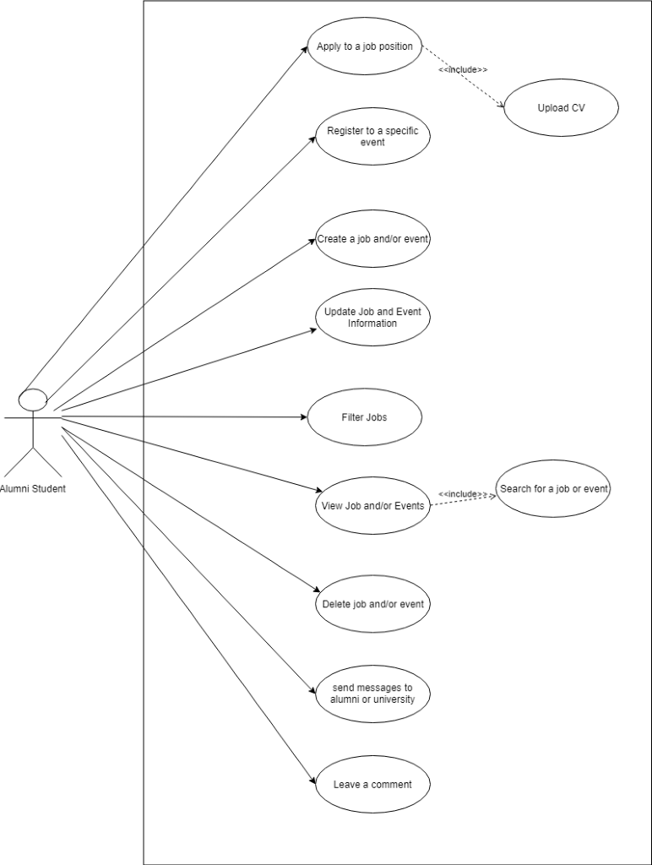

Use Case 2: Faculty Representative

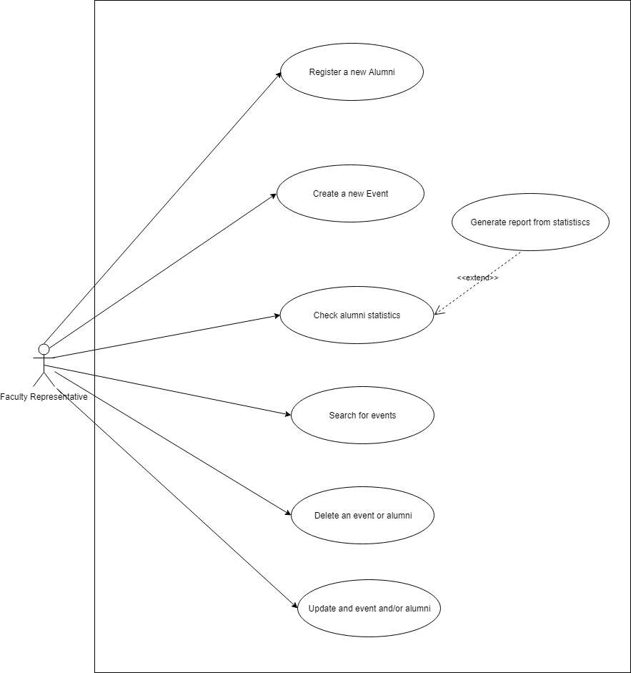

Use Case 3: CPAO
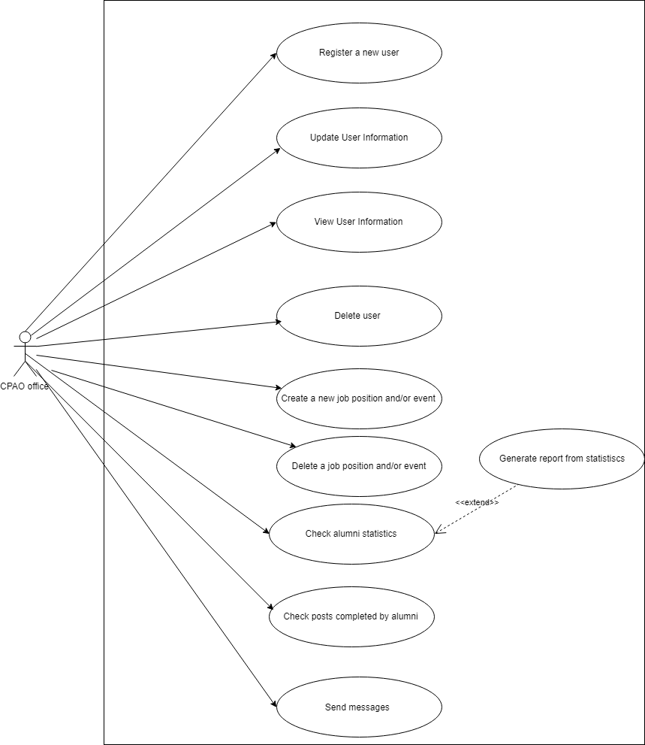

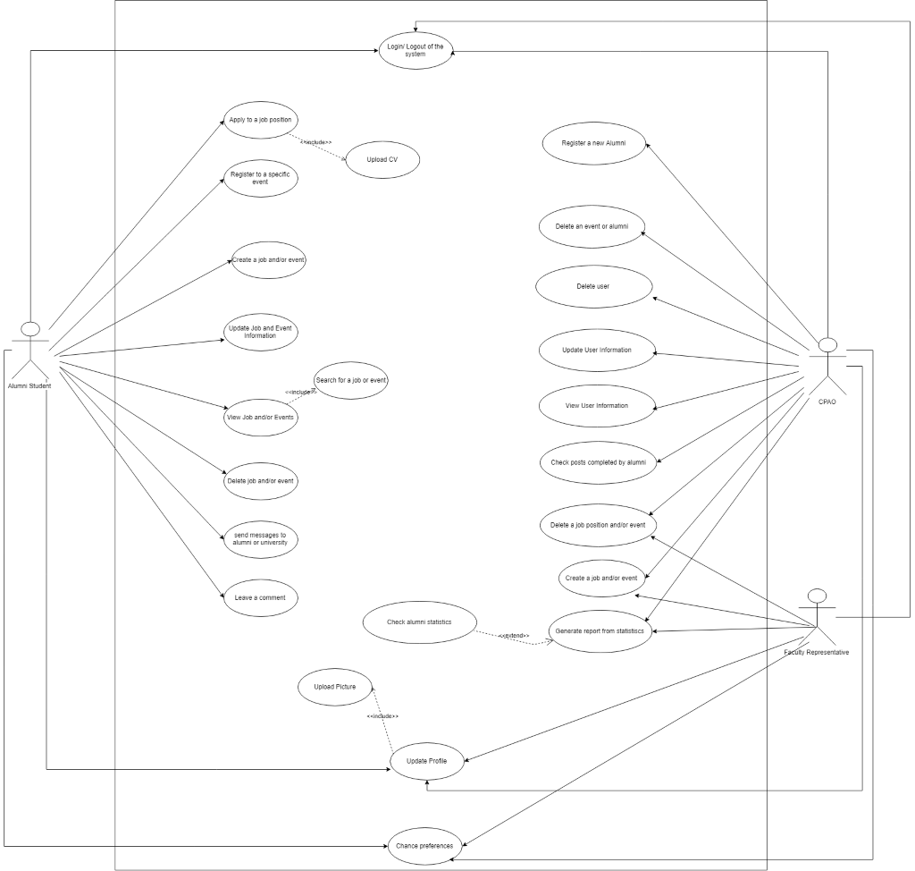
Use Case 4: General Use Case

4.3 Use Cases Extended

Use Case (UC_1.1): | Apply to a job position
Scope: | Alumni Management System
Level: | User level
Intention Context: | Any student who is seeking to find a job can apply to one of the job posts in the blog.
Minimum Guarantees: | Application is completed, but not sent to the employer.
Success Guarantees: | The student finishes the application., click submit and the application is sent to the employer.
Primary Actor: | Alumni Student
Stakeholder’s Interest: | To have applicant that can fit in a specific job requirement.
Precondition: | Alumni Student is logged in the system and At least one job is posted to the blog.

Use Case (UC_1.1.1): | Upload a CV
Scope: | Alumni Management System
Level: | User level
Intention Context: | Any student who is seeking to find a job can apply to one of the job posts in the blog.
Minimum Guarantees: | Student has clicked apply button to one job post.
Success Guarantees: | The CV is successfully sent and the application has finished.
Primary Actor: | Alumni Student
Stakeholder’s Interest: | To have applicant’s CV in his/her file in order to make e better decision.
Precondition: | Alumni Student is logged in the system.

Use Case (UC_1.2): | Register for a specific event.
Scope: | Alumni Management System
Level: | User level
Intention Context: | A student can decide to participate in one of the events that is shown in the blog by other alumni students or university itself.
Min Guarantees: | User has given a response, but it isn’t saved to the database.
Success Guarantees: | The student successfully has his/her response if going to a particular event.
Primary Actor: | Alumni Student.
Stakeholder’s Interest: | The organizer of the event can keep track automatically of who is coming to an event.
Precondition: | At least one event is posted at the blog in order to participate.

Use Case (UC_1.3): | Create a job position and and/or event
Scope: | Alumni Management System
Level: | User level
Intention Context: | Any alumni student can post his/her suggestion at the blog. Therefore, whoever knows about a vacancy he/she can immediately post and encourage other people to participate. Similarly, if they want to do an event on their own, they can create it.
Minimum Guarantees: | Student completes the form
Success Guarantees: | The job or event is successfully posted at the blog and other user can view and respond to it.
Primary Actor: | Alumni Student
Stakeholder’s Interest: | The graduated students communicate, share ideas and vacancies with each other.
Precondition: | Alumni Student is registered on AIS and is currently logged in the system.

Use Case (UC_1.4): | Update job position and/or event
Scope: | Alumni Management System
Level: | User level
Intention Context: | To improve a current posted post to fix any mistake or to extend the information provided to other users.
Minimum Guarantees: | The job or the event to be fixed has been posted once.
Success Guarantees: | The user makes necessary changes, click submit and the post is reposted in the edited version.
Primary Actor: | Alumni Student
Stakeholder’s Interest: | To have the best version of a post with a lot of information.
Precondition: | User must have posted the job at least

Use Case (UC_1.5): | Filter Jobs
Scope: | Alumni Management System
Level: | User level
Intention Context: | To create the possibility of a better searching in the blog system to find the post that is suitable to user field.
Minimum Guarantees: | The system responds with a query of posts.
Success Guarantees: | The system shows the jobs as filtered by user’s preferences
Primary Actor: | Alumni Student
Stakeholder’s Interest: | To view only specific job posts that match his/her interests
Precondition: | At least one job should have been posted to the system and the user should be logged in the system.

Use Case (UC_1.6): | View job positions and/or events
Scope: | Alumni Management System
Level: | User level
Intention Context: | To view details of the job posts and/or events being provided
Minimum Guarantees: | The job posts are shown but you can’t apply
Success Guarantees: | All the jobs and events are shown in the blog and the alumni students can easily interact with them
Primary Actor: | Alumni Students
Stakeholder’s Interest: | To get more information on the job posts and/or events from the blog
Precondition: | At least one job or event must be posted on the blog and the user should be logged in the system

Use Case (UC_1.6.1): | Search for a job position and/or event
Scope: | Alumni Management System
Level: | User level
Intention Context: | To facilitate the viewing preferences of the jobs or events in the blog
Minimum Guarantees: | The student enters a keyword but the system doesn’t show the jobs and/or events corresponding to that keyword
Success Guarantees: | The system filters the job posts and events according to the entered keyword and provides the list of job posts and events
Primary Actor: | Alumni Student
Stakeholder’s Interest: | To increase the searching efficiency
Precondition: | A valid keyword must be entered and the user should be logged in the system

Use Case (UC_1.7): | Delete job position and/or events
Scope: | Alumni Management System
Level: | User level
Intention Context: | The main goal is to remove from the system any entry which is incorrect or mistakenly entered in the system from an alumni student
Minimum Guarantees: | The system shows the list of posts and details to the user, but the user cannot delete any of them
Success Guarantees: | The alumni students enters correctly the query that must be deleted and the system after removes it from the database and the system, provides a success message to the user
Primary Actor: | Alumni Student
Stakeholder’s Interest: | To have removed any data that is no longer sufficient for the system
Precondition: | The user must be logged in the system and he/she should have opened the view tables in order to compete the process

Use Case (UC_1.8): | Send message to alumni/university
Scope: | Alumni Management System
Level: | User level
Intention Context: | The user must be logged in the system and he/she should have opened the view tables in order to compete the process
Minimum Guarantees: | The user sends a message, but it doesn’t go to the right destination. Therefore, the receiver does not receive any message
Success Guarantees: | The user successfully sends a message and the receiver can easily interact and send a message back
Primary Actor: | Alumni Student
Stakeholder’s Interest: | The main interest with its feature is to share ideas and opinions and students help each other in organizing events, or informing about new job positions
Precondition: | The user is already logged in the system

Use Case (UC_1.9): | Leave a comment
Scope: | Alumni Management System
Level: | User level
Intention Context: | Students can easily share their opinions in the posts by leaving a comment
Minimum Guarantees: | The student leaves a comment, but is not shown in the blog.
Success Guarantees: | The student leaves a comment and it is successfully posted in the blog
Primary Actor: | Alumni Student
Stakeholder’s Interest: | To have his opinions expressed in the blog for other students to see
Precondition: | At least one post must be added in the blog in order to start leaving comments

Use Case (UC_2.1): | Register a new alumni
Scope: | Alumni Management System
Level: | User level
Intention Context: | To be able to register a new student in the system and update all the information on the database
Minimum Guarantees: | The system shows the filling form for the alumni student
Success Guarantees: | The student data are successfully updated into the database and the student is entered in the system
Primary Actor: | Faculty Representative
Stakeholder’s Interest: | To be able to add a new alumni student with the correct information
Precondition: | The user should be logged in the system and enter all the required information

Use Case (UC_2.2): | Create a new event
Scope: | Alumni Management System
Level: | User Level
Intention Context: | To be able to add a new event post to the blog for all the students to view and participate
Minimum Guarantees: | The system shows the filling form for the event post
Success Guarantees: | The event data are successfully updated into the database and the event is entered in the system
Primary Actor: | Faculty Representative
Stakeholder’s Interest: | To be able to add a new event with the correct information
Precondition: | The user should be logged in the system and enter all the required information

Use Case (UC_2.3): | Check alumni statistics
Scope: | Alumni Management System
Level: | User Level
Intention Context: | To be able to view the alumni students statistics based on their job position, location, company, field of study etc.
Minimum Guarantees: | There are alumni student data entered in the database which will be used to generate statistics
Success Guarantees: | The user can view and export meaningful statistics based on the student data
Primary Actor: | Faculty Representative
Stakeholder’s Interest: | To make meaningful decisions based on the statistics provided in the blog
Precondition: | The user must be logged in and there should be registered students in the database

Use Case (UC_2.3.1): | Generate statistics reports
Scope: | Alumni Management System
Level: | User Level
Intention Context: | The user can view summarized reports based on the alumni statistics
Minimum Guarantees: | There are alumni students data entered in the database
Success Guarantees: | The user can download a report based on the statistics that he wishes to view
Primary Actor: | Faculty Representative
Stakeholder’s Interest: | To make meaningful decisions based on the statistics provided in the blog
Precondition: | The user is logged in the system and there are alumni student data entered in the database

Use Case (UC_2.4): | Search Event
Scope: | Alumni Management System
Level: | User Level
Intention Context: | To facilitate the viewing preferences of the events in the blog
Minimum Guarantees: | The user enters a keyword but the system doesn’t show the events corresponding to that keyword
Success Guarantees: | The system filters the events according to the entered keyword and provides the list of events
Primary Actor: | Faculty Representative
Stakeholder’s Interest: | To facilitate the viewing preferences of the events in the blog
Precondition: | A valid keyword must be entered and the user should be logged in the system

Use Case (UC_2.5): | Delete Event and/or alumni student
Scope: | Alumni Management System
Level: | User Level
Intention Context: | The main goal is to remove from the system any entry which is incorrect or mistakenly entered in the system
Minimum Guarantees: | The user performs the delete operation and provides information on the data that should be removed from the system
Success Guarantees: | The user enters correctly the query that must be deleted and the system after removes it from the database and the system, provides a success message to the user.
Primary Actor: | Faculty Representative
Stakeholder’s Interest: | To have removed any data that is no longer sufficient for the system.
Precondition: | The user must be logged in the system and he/she should have opened the view tables in order to compete the process.

Use Case (UC_2.6): | Update Event and/or alumni student
Scope: | Alumni Management System
Level: | User Level
Intention Context: | The user can change details about the event and/or the alumni student to more up to date information
Minimum Guarantees: | The user is shown the original details of the object he wishes to update but cannot save changes made
Success Guarantees: | The user enters up to date information about events and/or alumni students and the changes are saved in the database
Primary Actor: | Faculty Representative
Stakeholder’s Interest: | To make desired changes to existing information
Precondition: | The user must be logged in the system and there should be at least one record for an event/alumni student for changes to take place

Use Case (UC_3.1): | Register a new user
Scope: | Alumni Management System
Level: | User level
Intention Context: | To be able to register a new student in the system and update all the information on the database
Minimum Guarantees: | The system shows the filling form for the alumni student
Success Guarantees: | The student data are successfully updated into the database and the student is entered in the system
Primary Actor: | CPAO
Stakeholder’s Interest: | To be able to add a new alumni student with the correct information
Precondition: | The user should be logged in the system and enter all the required information

Use Case (UC_3.2): | Update user information
Scope: | Alumni Management System
Level: | User Level
Intention Context: | To improve a current user information in order to fix any mistake or to extend the information used for the CPAO statistics
Minimum Guarantees: | The list of users is shown to the CPAO, but he can’t make any changes
Success Guarantees: | The CPAO can make any changes to the user table and the changes are successfully saved to the database and shown in the system
Primary Actor: | CPAO
Stakeholder’s Interest: | The main interest of this use case is having an up to date list with correct information
Precondition: | At least one user is register in the system

Use Case (UC_3.3): | View User Information
Scope: | Alumni Management System
Level: | User Level
Intention Context: | CPAO can see a list with alumni and/or faculty representatives in order to have a representation of the database saved information
Minimum Guarantees: | A list of users is shown
Success Guarantees: | After clicking view user, a table with the user saved to the database is shown to the user
Primary Actor: | CPAO
Stakeholder’s Interest: | The user is able to view details to the users’ information and make any changes if wanted
Precondition: | At least one user must have been registered in the system

Use Case (UC_3.4): | Delete user
Scope: | Alumni Management System
Level: | User Level
Intention Context: | The main goal is to remove from the system any entry which is incorrect or mistakenly entered in the system from an CPAO
Minimum Guarantees: | The CPAO performs the delete operation and provides information on the data that should be removed from the system
Success Guarantees: | The CPAO enters correctly the query that must be deleted and the system after removes it from the database and the system, provides a success message to the user
Primary Actor: | CPAO
Stakeholder’s Interest: | To have removed any data that is no longer sufficient for the system
Precondition: | The user must be logged in the system and he/she should have opened the view tables in order to compete the process

Use Case (UC_3.5): | Create a new job position and/or event
Scope: | Alumni Management System
Level: | User Level
Intention Context: | To be able to add a new job/event post to the blog for all the students to view and participate
Minimum Guarantees: | The system shows the filling form for the job/event post
Success Guarantees: | The job/event data are successfully updated into the database and the job/event is entered in the system
Primary Actor: | CPAO
Stakeholder’s Interest: | To be able to add a new job/event with the correct information
Precondition: | The user should be logged in the system and enter all the required information

Use Case (UC_3.6): | Delete a job position and/or event
Scope: | Alumni Management System
Level: | User Level
Intention Context: | The main goal is to remove from the system any entry which is incorrect or mistakenly entered in the system from CPAO
Minimum Guarantees: | The CPAO performs the delete operation and provides information on the data that should be removed from the system
Success Guarantees: | The CPAO enters correctly the query that must be deleted and the system after removes it from the database and the system, provides a success message to the user
Primary Actor: | CPAO
Stakeholder’s Interest: | To have removed any data that is no longer sufficient for the system
Precondition: | The user must be logged in the system and he/she should have opened the view tables in order to compete the process

Use Case (UC_3.7): | Check alumni statistics
Scope: | Alumni Management System
Level: | User Level
Intention Context: | To be able to view the alumni students statistics based on their job position, location, company, field of study etc.
Minimum Guarantees: | There are alumni student data entered in the database which will be used to generate statistics
Success Guarantees: | The user can view and export meaningful statistics based on the student data
Primary Actor: | CPAO
Stakeholder’s Interest: | To make meaningful decisions based on the statistics provided in the blog
Precondition: | The user must be logged in and there should be registered students in the database

Use Case (UC_3.7.1): | Generate report from statistics
Scope: | Alumni Management System
Level: | User Level
Intention Context: | The user can view summarized reports based on the alumni statistics
Minimum Guarantees: | There are alumni students data entered in the database
Success Guarantees: | The user can download a report based on the statistics that he wishes to view
Primary Actor: | CPAO
Stakeholder’s Interest: | To make meaningful decisions based on the statistics provided in the blog
Precondition: | The user is logged in the system and there are alumni student data entered in the database

Use Case (UC_3.8): | Check posts completed by alumni
Scope: | Alumni Management System
Level: | User Level
Intention Context: | Since CPAO would be the admin of the system, he/she will have to control the operations done in the system in order to maintain the blog system efficiently
Minimum Guarantees: | The blog system is shown to CPAO
Success Guarantees: | CPAO can check in real time the latest post done by alumni and/or representative from faculty and analyze
Primary Actor: | CPAO
Stakeholder’s Interest: | To have an efficient and effective use of the blog system without malicious problems
Precondition: | Students have posted at least one post in the blog

Use Case (UC_3.9): | Send messages
Scope: | Alumni Management System
Level: | User Level
Intention Context: | The user can exchange messages with each other regarding the posts completed in the blog and for further information
Minimum Guarantees: | The user sends a message, but it doesn’t go to the right destination. Therefore, the receiver does not receive any message
Success Guarantees: | The user successfully sends a message and the receiver can easily interact and send a message back
Primary Actor: | CPAO
Stakeholder’s Interest: | The main interest with its feature is t share ideas and opinions and students help each other in organizing events, or informing about new job positions
Precondition: | The user is already logged in the system

Use Case (UC_4.1): | Update Profile
Scope: | Alumni Management System
Level: | User Level
Intention Context: | The user has complete control over his profile and he can update the information anytime, in case it has changed or is mistakenly put in the system
Minimum Guarantees: | The user is shown the update profile section in the profile
Success Guarantees: | The user successfully enters the new information and after clicking submit the profile is successfully updated
Primary Actor: | Alumni, CPAO, Faculty Representative
Stakeholder’s Interest: | The user can change the information displayed in the blog
Precondition: | The user has a profile already in the system

Use Case (UC_4.1.1): | Upload Picture
Scope: | Alumni Management System
Level: | User Level
Intention Context: | The user has complete control over his profile and he can update the information anytime, in case it has changed or is mistakenly put in the system
Minimum Guarantees: | The user is shown the update profile picture in the profile
Success Guarantees: | The user successfully enters the new information and after clicking submit the profile is successfully updated
Primary Actor: | Alumni, CPAO, Faculty Representative
Stakeholder’s Interest: | The user has always an updated profile with his information
Precondition: | The user has a profile already in the system

Use Case (UC_4.2): | Change Preferences
Scope: | Alumni Management System
Level: | User Level
Intention Context: | Change Settings about the notifications and messages
Minimum Guarantees: | The list of settings is shown
Success Guarantees: | The user’s preferences are changed according to his/her preference
Primary Actor: | Alumni, CPAO, Faculty Representative
Stakeholder’s Interest: | To update settings according to their preferences
Precondition: | The user has an account in the system and is currently logged in

Use Case (UC_4.3): | Receive notification and/or messages
Scope: | Alumni Management System
Level: | User Level
Intention Context: | The user is notified with the latest news from the blog
Minimum Guarantees: | There is a notification button in the page, but it doesn’t show the necessary information
Success Guarantees: | Any user can receive messages and/or notifications that will facilitate their usage
Primary Actor: | Alumni, CPAO, Faculty Representative
Stakeholder’s Interest: | There does exist an interaction with users, which will make the blog more flexible
Precondition: | The user is logged in the system

4.4 Data Flow Diagrams

a. DFD: Level 0
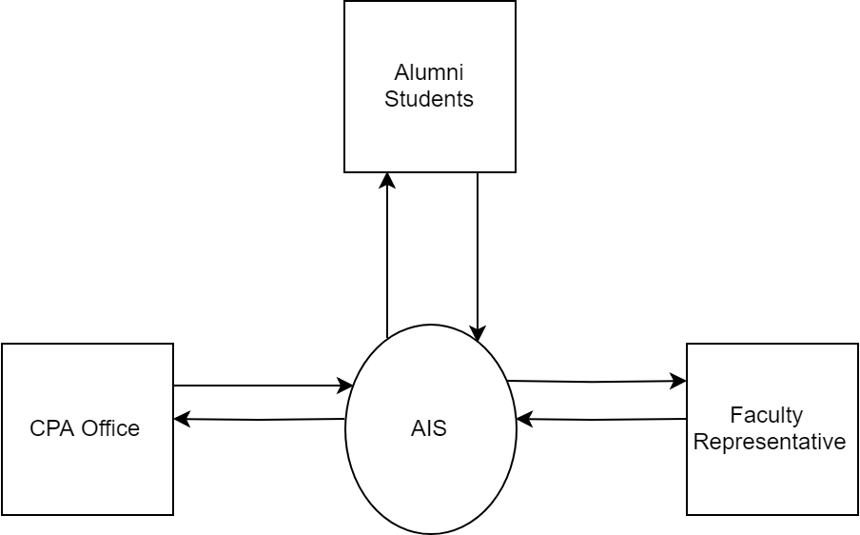

b. DFD: Level 1
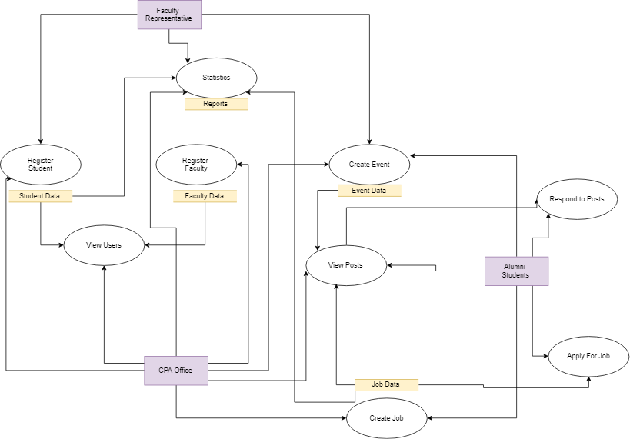

c. DFD: Level 2
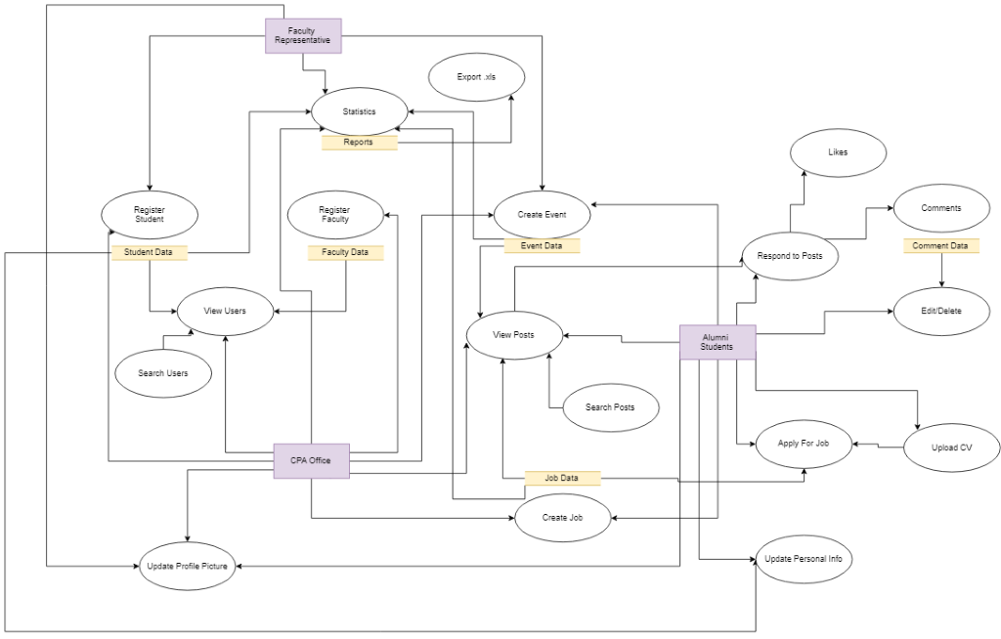

4.5 Entity-Relationship (ER) Diagram

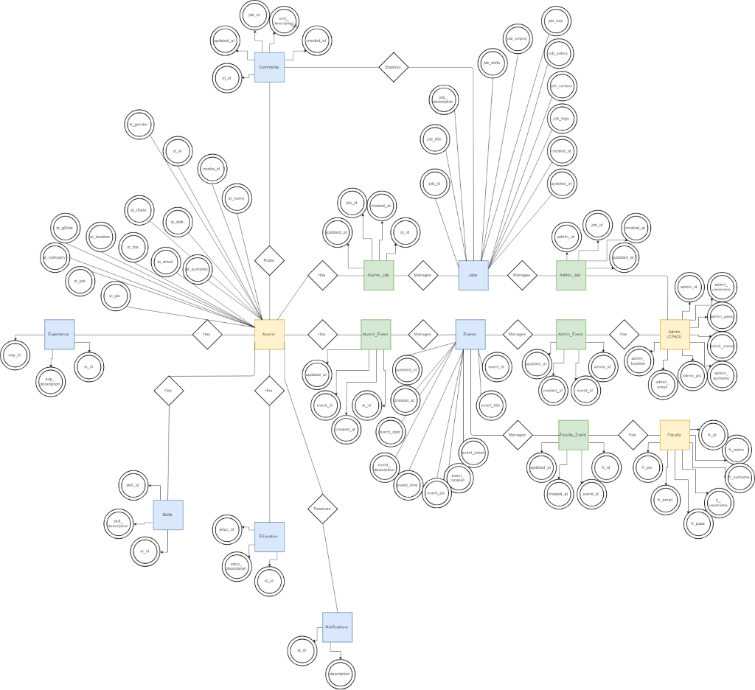

4.6 Activity Diagrams
Activity Diagram 1: Alumni Student
AC_1.1 and AC_1.1.1 : Job application procedure together with AC_1.5: Filter Job
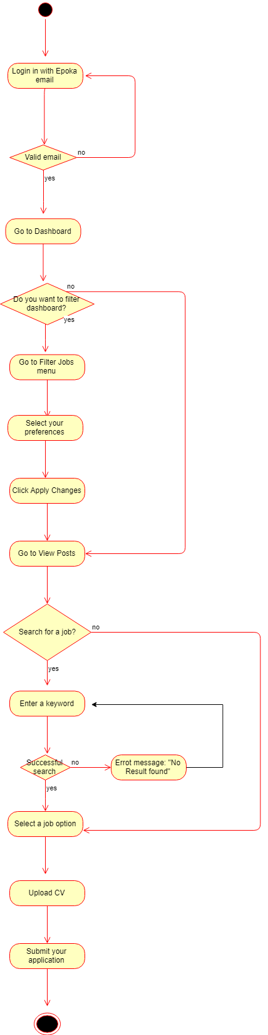

AC_1.2: Event registration
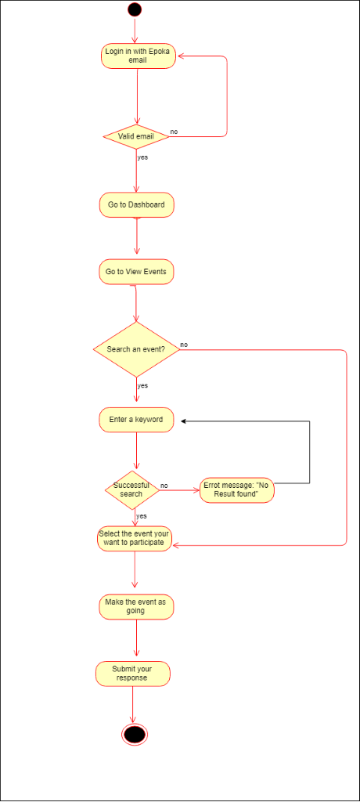

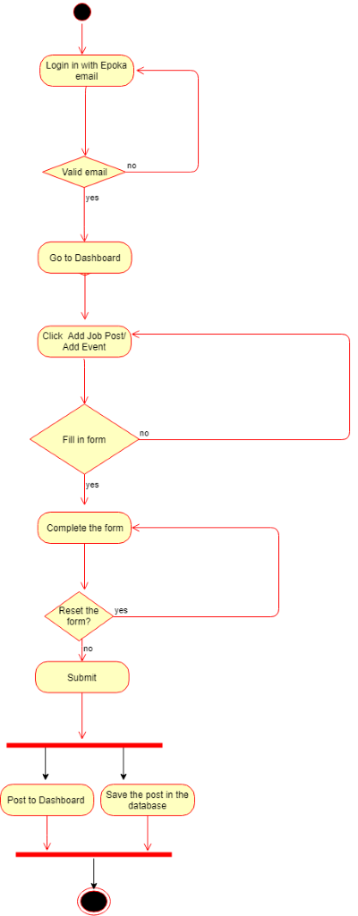
AC_1.3 Create a job post and/or event

AC_1.4: Update job posts and/or events
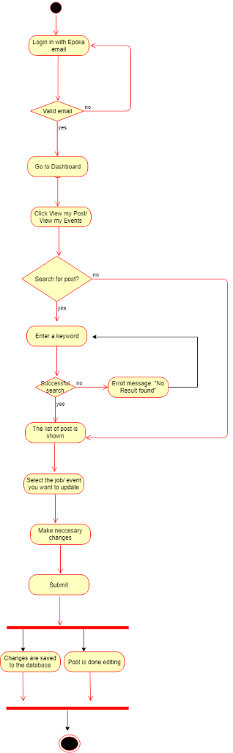

AC_1.6 and AC_1.6.1: View posts and search posts
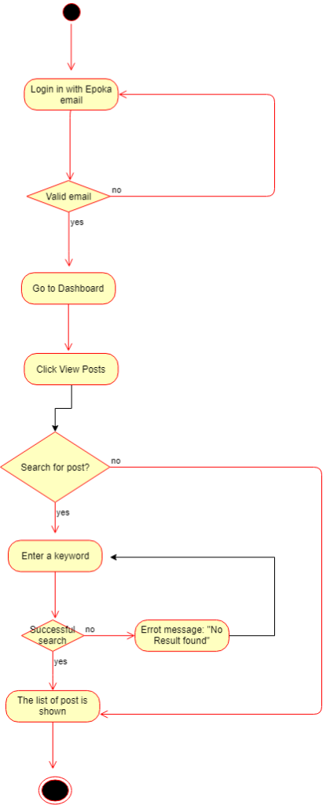

AC_1.7: Delete job position/ event
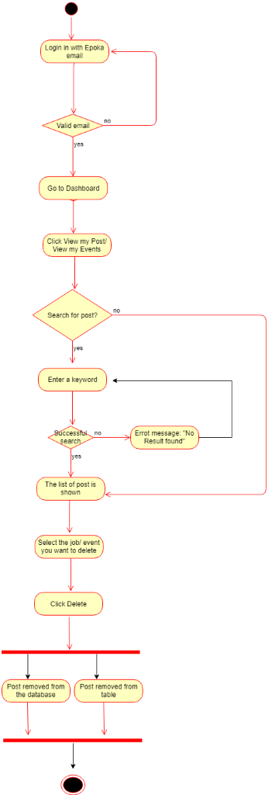

AC_1.8: Send a message
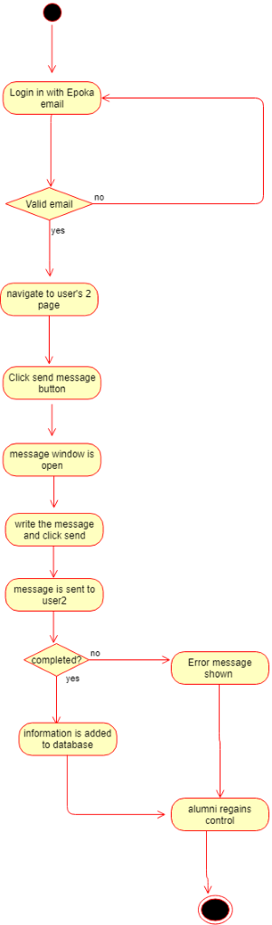

AC_1.9: Leave a comment

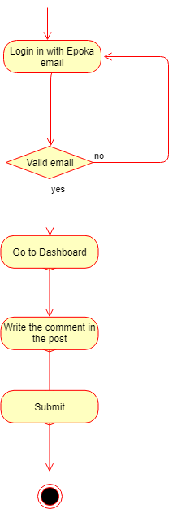

Activity Diagram 2: Faculty Representative
As we have stated earlier Faculty Representative is a part of the CPAO and performs some operations as the office to help CPAO. Therefore, the diagrams are shown in AC_3 for both Faculty and CPAO, in order to remove the duplicate diagrams issue.
AC_2.1: Register a new user (alumni student).
AC_2.2: Create a new event.
AC_2.3: Check Statistics.
AC_2.3.1: Download statistics report.
AC_2.4: Search event.
AC_2.5: Delete event.
AC_2.6: Update event.
Activity Diagram 3: CPAO
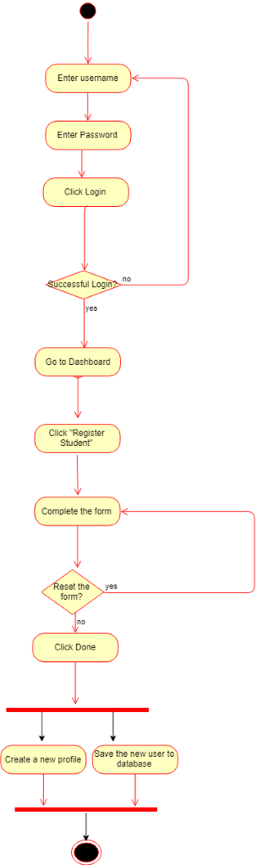
AC_3.1: Register a new user (Alumni Student or Faculty Representative) (and AC_2.1)

AC_3.2: Update User Information (Alumni Student or Faculty Representative)
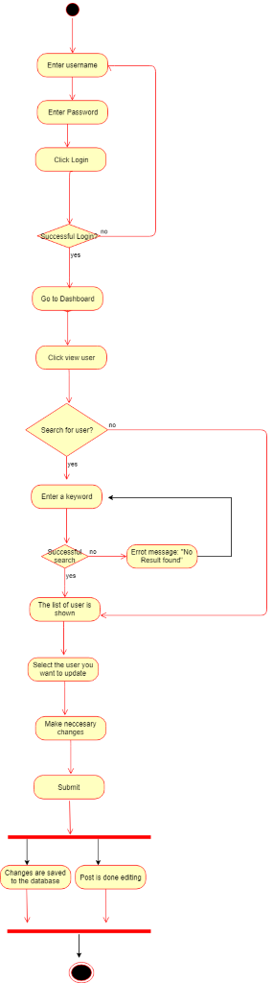

AC_3.3: View User Information and AC_3.3.1: Search User (Alumni Student or Faculty Representative)
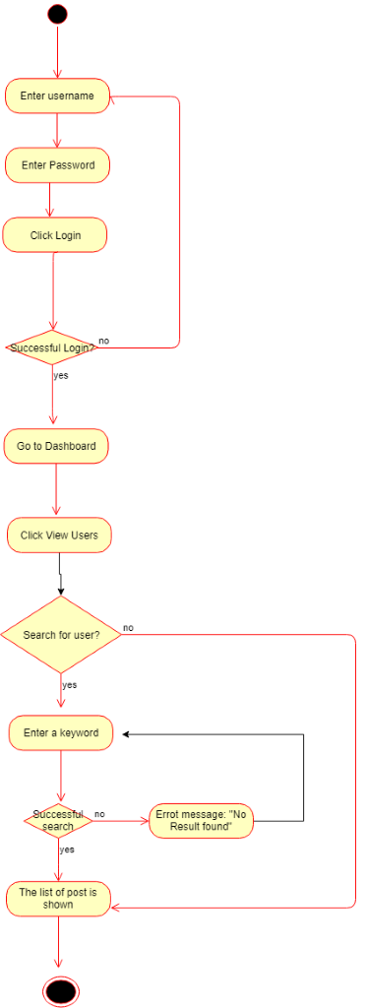

AC_3.4: Delete User (Alumni Student or Faculty Representative)
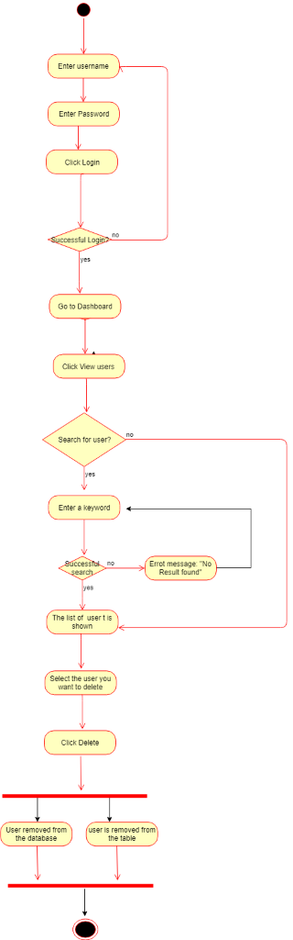

AC_3.5: Create a new Job Post and/or event ( and AC_2.2)
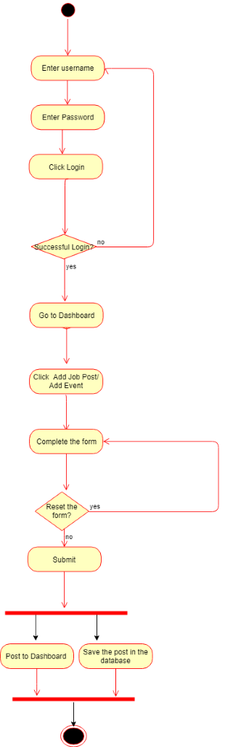

AC_3.6: Delete a job post and/or event (and AC_2.5)

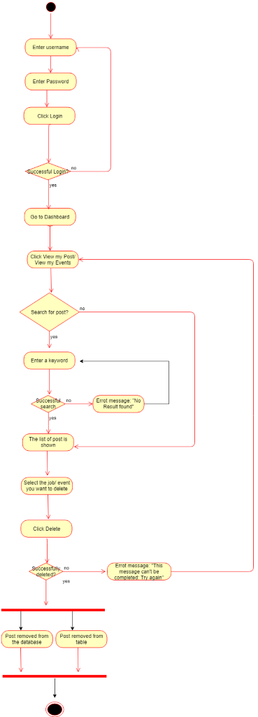

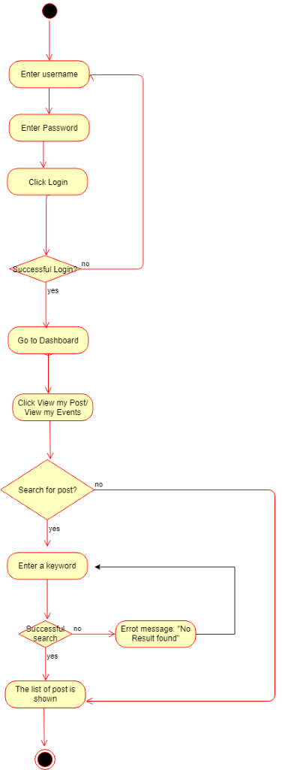
AC_3.7: View posts and AC_3.7.1: Search posts (and AC_2.4)

AC_3.8: Update Posts (and AC_2.6)
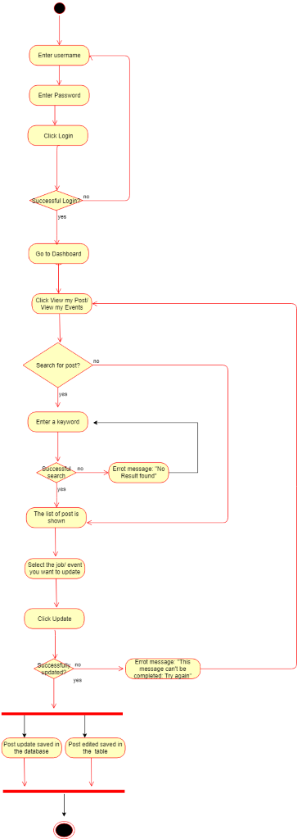

AC_3.7: Check Statistics AC_3.7.1: Download statistics (and AC_2.3 + AC_2.3.1)
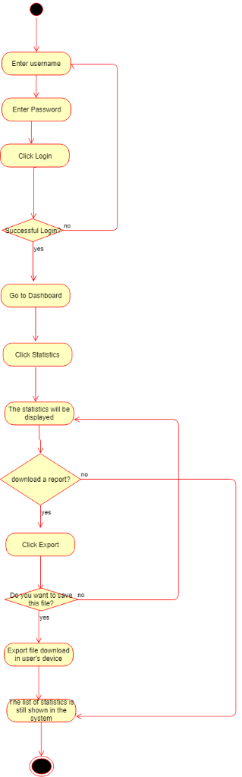

AC_3.8: Check posts completed by alumni
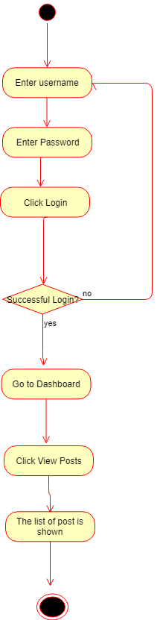

AC_3.9: Send a message
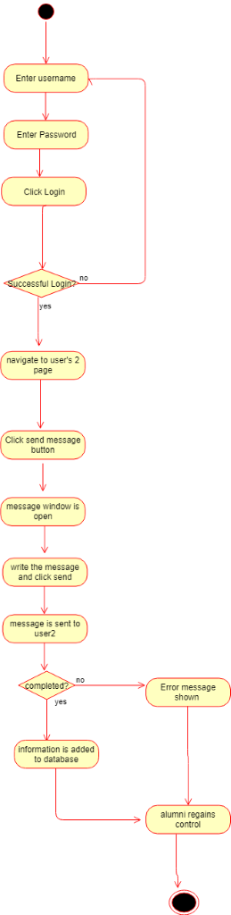

Activity Diagram 4: General User
AC_4.1: Update Profile and AC_4.1.1: Upload an Image
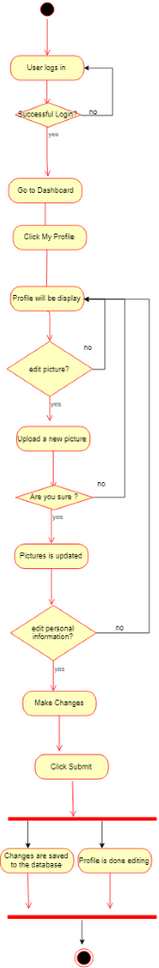

AC_4.2: Change Preferences

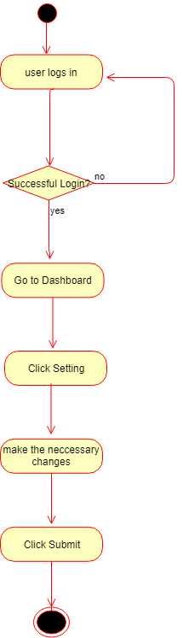

4.7 State Charts
Alumni
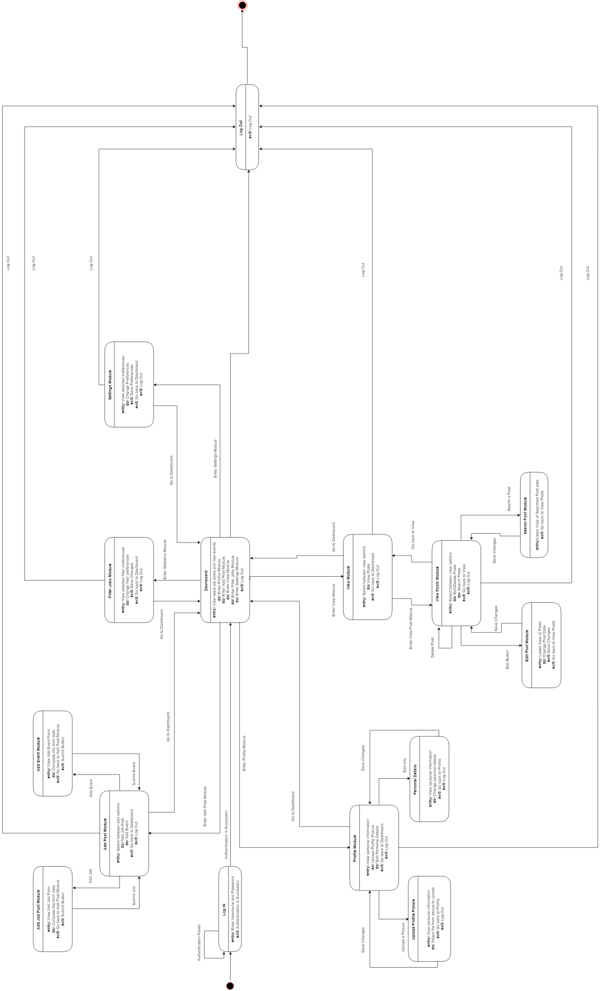

CPAO
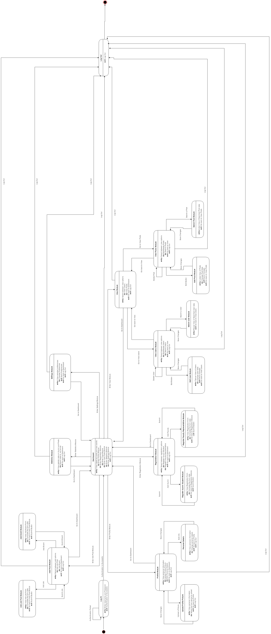

Faculty
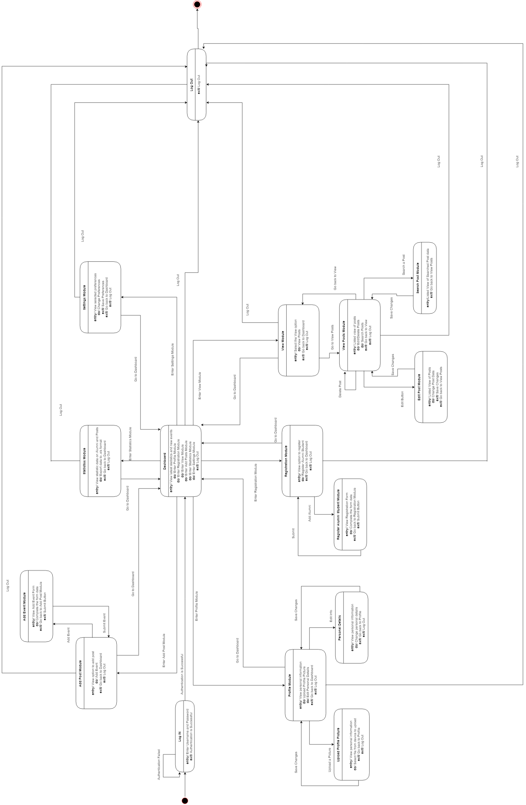

4.8 Sequence Diagrams

Alumni

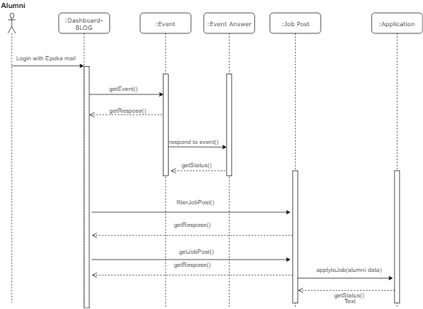

Faculty

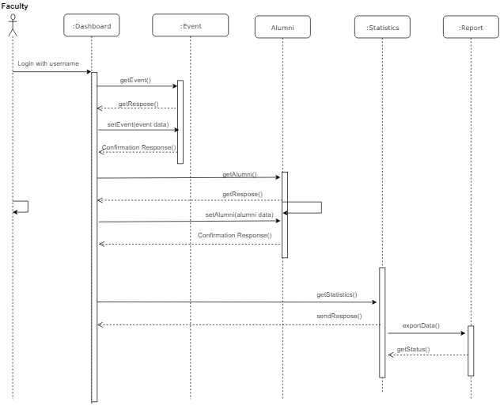

CPAO
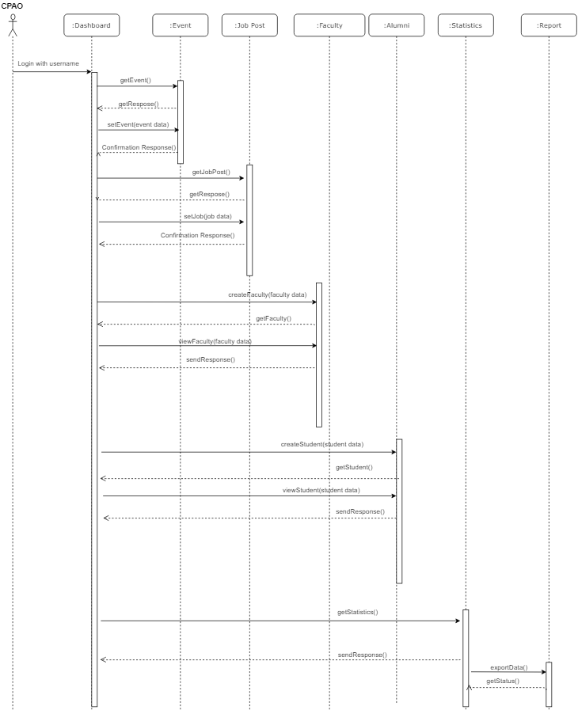

4.9 Collaboration Diagrams

Alumni-Job Post- Event- Application

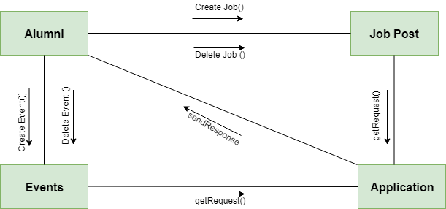

CPAO-Job Post- Event- Statistics

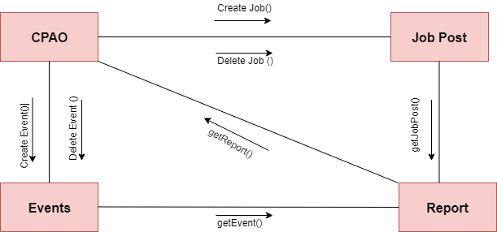

CPAO-Alumni-Faculty- Statistics

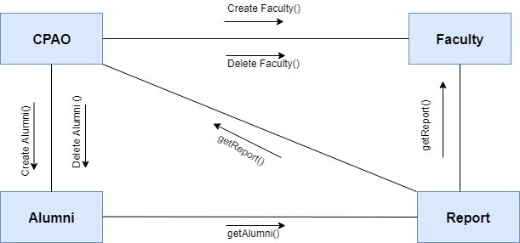

Faculty- Event- Alumni-Statistics

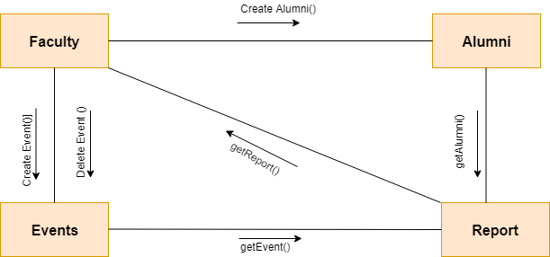

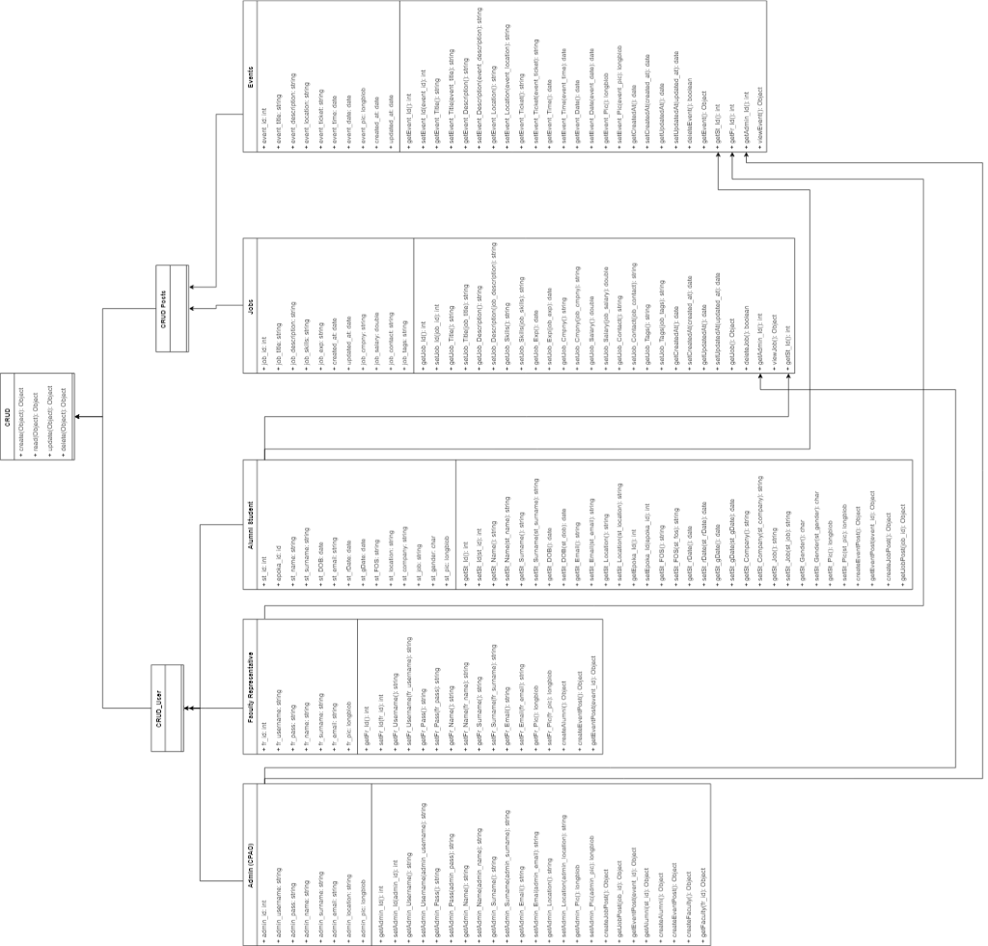
4.10 Class Diagram

4.11 Object Diagram
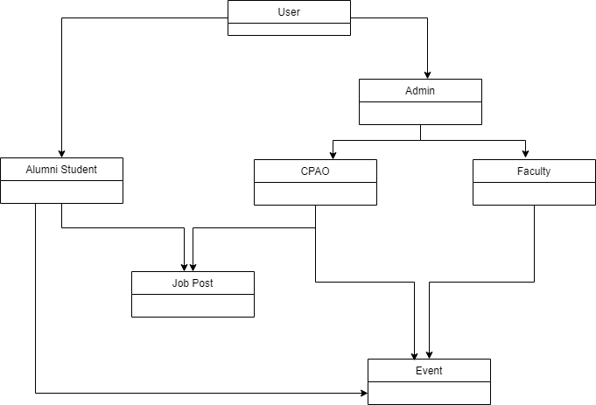

4.12 Component Diagram

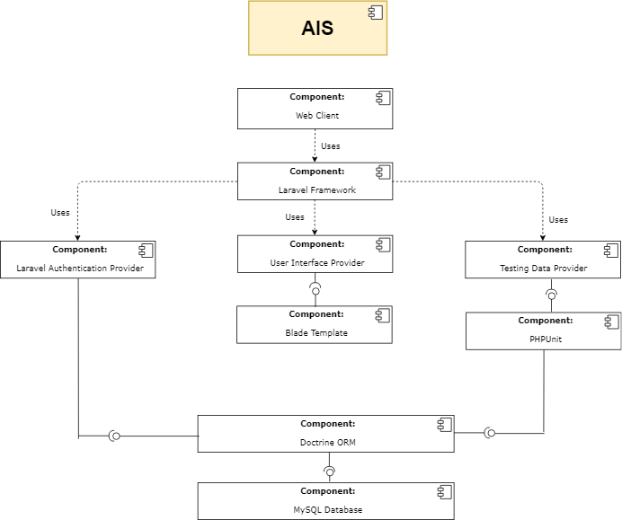

4.13 Deployment Diagram

